CACA-UAN：A Context-Aware Communication Approach to Efficient and Reliable Underwater Acoustic Sensor Networks
Qi Liu*
Jiangsu Collaborative Innovation Centre of Atmospheric Environment and Equipment Technology (CICAEET),
School of Computer and Software,
Nanjing University of Information Science & Technology, 210044, China,
E-mail: qi.liu@nuist.edu.cn
*Corresponding author
Xuedong Chen
School of Computer and Software,
Jiangsu Engineering Centre of Network Monitoring,
Nanjing University of Information Science & Technology, 210044, China,
E-mail: 1554667161@qq.com
Xiaodong Liu
School of Computing,
Edinburgh Napier University, 10 Clinton Road, Edinburgh EH10 5DT, UK,
E-mail: x.liu@napier.ac.uk
Nigel Linge
School of Computing, Science and Engineering,
The University of Salford, Salford, Greater Manchester, M5 4WT, UK,
E-mail: n.linge@salford.ac.uk

Abstract: Underwater Acoustic Sensor Networks (UANs) have emerged as a promising technology recently which can be applied in many areas such as military and civil, where the communication between devices is crucial and challenging due to the unique characteristics of underwater acoustic-based environment, such as high latency and low bandwidth. In this paper, context awareness is applied to the design of an underwater communication approach, called Context-Aware Communication Approach for a UAN (CACA-UAN), which aims to improve the overall performance of the underwater communication. According to the results, the proposed CACA-UAN can increase the efficiency and reliability of the underwater communication system.
Keywords: context-aware; underwater acoustic sensor network; context-aware communication; efficiency; reliability
Reference to this paper should be made as follows: Liu, Q., Chen, X. D., Liu, X. D. and Linge, N. (2016) ‘CACA-UAN：A Context-Aware Communication Approach to Efficient and Reliable Underwater Acoustic Sensor Networks’, Int. J. Sensor Networks, Vol. X, No. Y4, pp.000–000.
Biographical notes: Qi Liu is presently a professor at the Jiangsu Collaborative Innovation Centre of Atmospheric Environment and Equipment Technology (CICAEET), and the School of Computer and Software, Nanjing University of Information Science & Technology, China. His research interests include context-awareness, data communication in MANET and WSN, smart home and energy efficiency. He also devotes time to WSN solutions on intelligent agriculture. He is a member of IEEE and ACM.
Xuedong Chen obtained his B.S. degree in the school of Computer and Software from Nanjing University of Information Science and technology in 2014. Since 2014, he has been in the school of Computer and Software studying for the M.S. degree. His current research interests include the context awareness, communication protocol design in underwater sensor network.
Xiaodong Liu is a reader and the director of Centre for Information & Software Systems in School of Computing at Edinburgh Napier University. His research interests include context-aware adaptive services, service evolution, mobile clouds, pervasive computing, software reuse, and green software engineering. He is a member of IEEE Computer Society and British Computer Society.
Nigel Linge is a professor of Telecommunications at the University of Salford. He received respectively the BSc and PhD in 1983 and 1987. He is an electronic engineer by profession and has research interests in network design, context-aware information systems, communication protocols, mobile systems and practical applications of networking technology in areas such as energy and building monitoring. He also devotes time to the preservation and dissemination of the history of telecommunications and provides external advice to organization on their heritage strategies. He is a Fellow of the IET and BCS.
This paper is a revised and expanded version of a paper entitled “CACA-UAN：A Context-Aware Communication Approach Based on the Underwater Acoustic Sensor Network” presented at the 2nd International Conference on Cloud Computing and Security (ICCCS 2016), Nanjing, China, on 29 July, 2016.

1 Introduction
Recent development of terrestrial wireless sensor networks (WSN) and precision electronic equipment, deploying sensor nodes under the water has gradually matured, which makes communication between underwater nodes become feasible. As a new and emerging field, underwater acoustic sensor networks (UAN) have attracted attentions and well applied in the fields of marine environment monitoring and data acquisition, underwater exploration, disaster prevention, seismic monitoring, assistive navigation and etc. Compared with the traditional terrestrial WSN (Guo et al., 2014), the UAN has the following characteristic, including high deployment cost, high delay and drop packet rate due to its acoustic medium (Luo et al., 2014), and mobility due to current flows. These features also become challenges since traditional solutions for the terrestrial WSN cannot be used for the UAN directly (Mandal and De, 2015). Practical schemes have been proposed to manage the challenges, e.g. the two-step security model for time synchronization (Hu et al., 2008), the tracking algorithms for tracking mobile targets (Huang et al., 2008), the precise prototype localiser model (Prabha et al., 2013), and the energy-efficiency routing schema without location information (Al-Bzoor et al., 2015).
In an underwater acoustic sensor network, sensor nodes cooperate with each other to guarantee the overall performance of the communication network (Wang et al., 2013; Zhang et al., 2016). Each node perceives predefined environmental information, and then communicates with its neighbours in order to share the sensed data between the sensor nodes or with an Autonomous Underwater Vehicle (AUV), which collects and aggregates the sensed data from the regular nodes and then transmits back to the user or the display terminal. The reference architecture of a three-layer UAN with AUVs is shown in Figure 1, where anchored underwater sensors, AUVs, surface buoys and surface sinks are deployed sparsely in the water to perform the collaborative data transmission (An et al., 2013; Qu et al., 2016). An adaptive communication approach is required to enable generic information exchange in such a heterogeneous environment.
The concept of context awareness as a core feature in ubiquitous networks and pervasive computing systems, was introduced by Schilit in 1994 (Schilit et al., 1994) and has been well developed and applied to the variety of fields, e.g. the social networks (Roussaki et al., 2012; Han et al., 2014; Semiari et al., 2015), the web services (Zhang et al., 2013; Han et al., 2014; Misra et al., 2014), and the wireless sensor network (Fanelli et al., 2013; Liu et al., 2013; Li et al., 2014; Iturri et al., 2016), etc. In recent years, investigation that applies context awareness to UAN has also been conducted (Hu et al., 2007; Noh et al., 2014; Li et al., 2016), which mainly focuses on throughput and energy saving.
In this paper, context awareness is employed to share information between UAN nodes. An ontology-based context-aware model is proposed to represent and store UAN related context information. A sharing scheme and corresponding context-aware communication protocol are also presented to achieve efficient and reliable collaboration between UAN nodes.
The work of this paper focuses at the design, simulation, test and evaluation of a context-aware communication method in an underwater acoustic sensor network. In section 2, related work is discussed, followed by the proposed context-aware model called CACA-UAN, including an ontology-based context model and a context-aware communication mechanism in section 3. In section 4, the simulation and performance evaluation of the CACA-UAN are offered, before concluding in section 5.
2 Related Work
Compared to regular WSNs, UANs suffers from following constrains:
1) High delay due to low transmission of sound in water;
2) High bit error rate caused by multipath and attenuation;
3) Limited battery life, and hard to be recharged;
4) Prone to failure in certain harsh environments.
In terms of crucial communication between the devices in a UAN, a proper communication media need to be carefully selected. Three models have been deployed in UANs, involving radio frequency (RF) (Wang et al., 2015; Kwak et al., 2016), optical wave (Simpson et al., 2012; Tang et al.,

Figure 1 The Architecture of Three-Dimensional UAN with AUVs

2014) and acoustic wave (Qarabaqi and Stojanovic, 2013; Ebihara and Mizutani, 2014). The RF transmission under the water is different in the air, which has higher attenuation and shorter transmission distance. Long-distance RF communication through conductive salty water was presented using a large antenna and high transmission power (Xiao et al., 2012), propagating at ultra-low frequencies (30-300Hz). The optical wave communication under the water has its advantage (e.g. slow decay), but suffers from reflection, refraction and scattering (Kaushal and Kaddoum, 2016). The acoustic communication is widely used underwater currently due to its low signal loss and long propagation in water (Walree and Otnes, 2013; Dol et al., 2013), but also has its shortage on limited bandwidth, high delay and time-varied multipath and fading. Investigation on efficient and reliable underwater acoustic communication has been undertaken (Chen et al., 2014).
Communication protocols at the MAC layer in an underwater network have been well investigated in order to provide efficient node-to-node interaction (Kantarci et al., 2011; Ojha et al., 2013), which can be separated into two categories: contention-based and schedule-based (Liu et al., 2013). Slotted FAMA (Molins and Stojanovic, 2006) is a CSMA-based MAC protocol, which combines the carrier sensing and a dialogue to relieve collision. Before data transmission, the source node sends a control packet to the receiver to avoid the receiver receiving at the same time. Although the packet collisions are decreased, the transmissions of multiple control packets can lead to low system throughput. UW-MAC (Pompili et al., 2009) is a distributed CDMA-based MAC scheme, and is the first protocol of leveraging the CDMA properties to implement multiple access to the scare bandwidth under the water, which achieves a trade-off among high throughput, low delay and energy consumption by the means of incorporating the optimal transmit power and code length. ALOHA is a simple contention-based protocol, and is demonstrated that it can work on underwater sensor networks (Gibson et al., 2007; Xie et al., 2009). The p-persistent ALOHA is an enhanced Aloha protocol for multi-hop UANs (Xiao et al., 2011), which can effectively reduce collisions during the data transmission by coordinating the operations among nodes. Although the high throughput is achieved as the increasing of the network load, the challenge of latency will be increased.
Although existing communication approaches are useful to address the low communication bandwidth and high access delay, still to be improved and developed so as to provide better underwater communication service to the user. For UANs, reliable and efficient communication technologies (Xie and Wang, 2014; Shen et al., 2015; Han et al., 2015) are crucial to be developed to implement data transmissions and improve the overall performance of the communication system. In this paper, we propose CACA-UAN, a context-aware communication approach for under-water acoustic sensor network which includes an ontology-based context modelling approach, the context-aware communication system architecture, context-aware device association, and context-aware communication mechanism, and we mainly focus on how to apply context awareness to the underwater communications, and exploit context information to improve the performance in term of delay, jitter and the packet-drop rate.
3 Context-Aware Communication Approach
In this section, a Context-Aware Communication Approach to Underwater Acoustic Networks (CACA-UAN) model is proposed which integrates context awareness into our underwater communication approach, including a context-aware model, its communication mechanism and related device association.
3.1 CACA-UAN Overview
To tackle the challenges mentioned above in the underwater communication section, the CACA-UAN model is proposed, which incorporates the context-aware concept with existing underwater communication technologies by applying context awareness to the overall design of the communication system, including context-aware communication association and context-aware data transmission. The CACA-UAN primarily focuses on novel functionality at the medium access control layer relying on an underwater acoustic channel, in order to offer efficiency and reliability to the existing communication system. As shown in Figure 2, a system architecture design for context-aware underwater communication is presented, where context information can be used and exchanged during communication association and data transmission.
In the CACA-UAN, context information related to underwater devices/nodes and networking components is fully exploited. A cluster in the CACA-UAN is firstly formed in accordance with similar services based on shared context information from proximate nodes. The header of such a cluster is then selected, considering rich context of the cluster, e.g. signal strength, location and energy level, etc. After that, the cluster header is responsible for managing the context information of other devices in the cluster and coordinating the inter- and intra-cluster communication. It also reports node failure to the AUV e.g. low-lever energy of a device or broken device due to the harsh environment. When an AUV joins into the network, it can broadcast and receive desired context data from designated devices. Such information is then forwarded to the user for further decision-making and responses.
3.2 A Context-Aware Model and Its Context Information
According to Dey (Abowd et al., 1999), a context-aware system can provide rational services to improve overall performance and efficiency of the system due to its efforts

Figure 2 The System Architecture of Context-aware Underwater Communication

on exploiting, modelling, integrating and exchanging corresponding context information among the system. In a UAN network, a context-aware model is also essential to facilitate the interaction of the communication system.
Existing context models and schemes, such as the dirichlet mixture model (Miotto and Lanckriet, 2012), the tree-based context model (Choi et al., 2012), and the interaction model (Zhang et al., 2013), etc., are only targeted on particular environments, but lack of common context-aware approaches. In the paper, an ontology-based context modelling approach to a UAN network, where four basic interrogative dimensions, i.e. Who, When, Where and What are exploited to represent and retrieve four basic aspects of context information within an underwater sensor acoustic network, involving identity, time, location and related characteristics of nodes/devices.
A hierarchy and index scheme is used to abstract context information into many parameters, which are classified into several context levels (e.g., service, energy and location, etc.). Each context parameter is assigned with an identifier to ensure the uniqueness of context information, therefore the context parameters of all devices can be registered with no interference and it is beneficial to maintain the context information. A simple model is generated, as shown in Figure 3.
Figure 3 The Context Information Tree
The context information contains following components:
- Service Level: context and identifiers are used to represent the categories of services that a device can provide (e.g., the temperature acquisition);
- Application Level: context and identifiers are used to represent the classification of applications;
- Contents Level: context and identifiers at this level are used to represent the characteristic of a particular application or a device (e.g., location, energy or storage);
- Inherent attribute Level: context and identifiers are used to represent the inherent attribute of the device (e.g., level).
Figure 4 shows the context information and identifier of application 1, where the index of the context information is assigned following dotted format. For example, the ID of Service 1 is assigned 1, whereas the ID of Energy in Application 1 is 1.1.3.
As mentioned earlier, context information can be used for the communication association and data transmission. The new proposed context model approach for the UAN which is based on the hierarchy and index scheme are useful and effective for the CACA-UAN.
Figure 4 The context information of the service type 1 on application 1
3.3 Context-Aware Communication association
Context-aware communication is a process of interaction on associated devices, where communication association needs to be established before communication. In the CACA-UAN, an idea of a handshake protocol is exploited to establish a reliable association, which is divided into three phases, involving service discovery, connection establishment and connection termination. An example of the process of communication association is presented in Figure 5.
3.3.1 The context-aware service discovery
The initial phase is service discovery before the communication association, which is triggered when a new device joins to the network. The goal of the context-aware service discovery is to exploit related context information so find surround devices and is prepared for the next phase.
At the procedure, each device plays double roles. One is to discover surround service-desired devices, and the other is to be discovered as a desired device by surround devices. Either active “to discover” or passive “to be discovered” mode can be converted/switched on certain conditions.
The proposed context-aware service discovery phase in the paper consists of the following three stages:
1. device searching for desired service;
2. the selection of leader between the searched devices with the desired service;
3. the AUV adds into the network.
A device first enters the stage of the device searching actively, and searches service-desired devices based on the service context information by checking the beacon broadcast of the other devices. If these desired devices are discovered, a virtual cluster is formed in accordance with the same service; if not, the device will convert to the passive discovery mode. On the second stage, the header of each cluster is selected according to location and energy context, aiming at a balance between the signal strength and the energy. The cluster header can manage the context information of devices in the cluster and coordinates the communication between inter-cluster or intra-cluster devices. Internal devices of a cluster can discover a service-desired device from the cluster header. The third stage initialises only when an AUV is connected to the cluster, requiring context data from corresponding devices. When the AUV adds into the network, it broadcasts a beacon to all clusters for desired services. Cluster headers check the beacon firstly to determine whether the cluster is the candidate. Once the cluster is correctly determined, its header selects the desired context information (e.g. Service ID, Application ID, etc.) to form an AUV-device report list, and transmit it to the AUV.
The process of the service discovery is shown at Algorithm 1.
Algorithm 1 context-aware service discovery of device k
begin
initialisation
setup a time threshold
loop
if device k searches surrounding service-desired devices actively in a time threshold then
device k receives and checks the beacons from the neighbours
if desired-devices of device k is discovered
a cluster is formed based on the same service context ID of the devices by the algorithm 2
if a device can keep the balance of the signal strength and the energy between the intra-devices then
the device is selected as the cluster header, and device k can obtain a device-device list table with the cluster header
end if
end if
else
after the time threshold, the status of device k can convert its mode to passive discovery
end if
end loop

The matching algorithm is listed at Algorithm 2.
Algorithm 2 The matching algorithm happens on device i when it receives the beacon from another device j
begin
initialisation
setup device-device list table
loop
if device i receives a beacon from device j then
compare the Service ID of the beacon with Service ID of the desired-service device i
if the service ID is not equal to the desired service ID then
device i drops the beacon from the device j, and receives the beacon from other devices
else
compare the Application ID of the beacon with Application ID of the desired-service device i
if the application ID is not equal to the desired application ID
then
device i drops the beacon from the device j, and receives the beacon from the other device
else
device j is added to the device-device list table of device i.
end if
end if
end if
end loop
3.3.2 Context-aware connection establishment
The context-aware connection establishment is the second phase of the communication association, where a device-device list is exploited and shared between devices and an AUV-device list is established between the devices and the connected AUV.
In each cluster, the header manages the context information of cluster devices, so the devices can share and update the device-device list with the header. Each device selects its next-hop device from the device-device list based on certain criteria, such as traffic load, link status and so on. With regard to the AUV-device list, it is established once the connected AUV receives responses from desired devices.
As long as the context information of a device is changed, a context-aware association update procedure is triggered to inform corresponding devices. During the procedure, the updated context information of the device is sent to all associated devices. A successful update response is feedback once the procedure is done.
3.3.3 Context-aware connection termination
The connection termination is the final phase of the communication and happens due to inadequate energy or other failures. If a device moves out of the communication range of the cluster, the disconnection procedure can still be conducted, but the association context information is stored by both devices for a pre-defined period of time. If the device moves back to the cluster, the connection is re-established by the stored association context. If the AUV receives a command from a user requesting to return or an urgent message from an associated device that needs reporting to the user, a disconnection procedure is called until new commands are received.

Figure 5 An example of the process of communication association

4 Simulation and Performance Evaluation
In order to evaluate the performance of the proposed CACA-UAN, a discrete-event cluster simulator, called Aqua-Sim (Xie et al., 2009) developed based on the NS-2 simulation platform is established. The CACA-UAN has been integrated into the Aqua-Sim so scenarios can be designed and simulated to conduct the comparison and evaluation work between the CACA-UAN and default models (i.e. ALOHA and UWAN) in the Aqua-Sim.
4.1 Simulation Environment
A simulation area of 100m×100m×100m is set up in the Aqua-Sim, whilst the simulation time is set to 500s. Three criteria are selected as for the comparison and performance evaluation, involving Jitter (JT), Packet Transmission Delay (PTD), and Dropped Packet Ratio (DPR). Major parameters used by the simulations are shown in Table 1.
4.2 The validation of efficiency
In this section, the efficiency validation of the underwater communication system is presented. Two experiments have been conducted in terms of the end-to-end delay on different conditions. As shown in Figure 6, the delay of each generated packet is presented, where it can be seen that the CACA-UAN has shown better performance than the other two protocols due to efficient employment of context information during communication. In the same simulation
Table 1: Simulation Parameters
Parameters | Value
Simulation Area | 100m×100m×100m
Simulation Time | 500s
Mobility Model | Random mobility model
Packet Size | 50bytes
Communication Range | 20m
Node Speed | 0.5m/s
Transmission Power | 2.0mw
Receiving Power | 0.75mw
Idle Power | 0.008mw
Data Rate | 0.1kbps
time, the number of the packets generated by the CACA-UAN is more than the ALOHA and especially much more than the UWAN.
Figure 6 The average end-to-end delay of each generated packet with the data rate=0.1
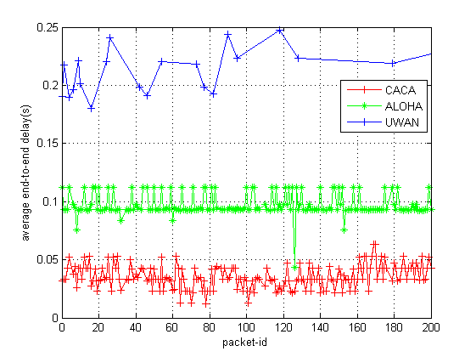
Figure 7 The average end-to-end delay of each generated packet in different data-rate
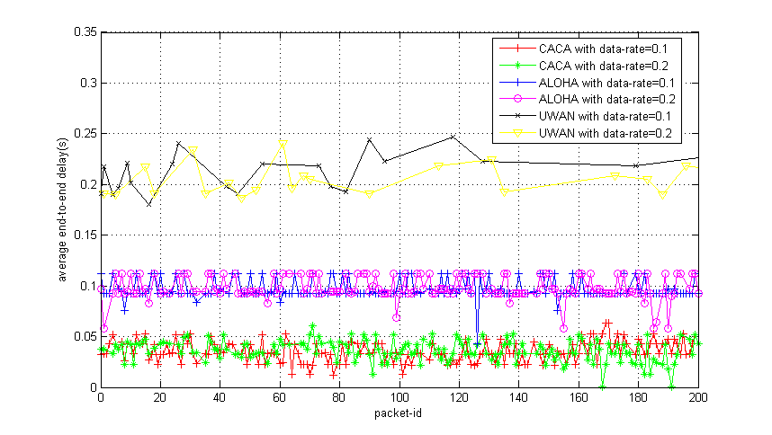
Figure 7 illustrates average end-to-end delay with different data-rates. With the increasing of the data-rate, the CACA-UAN is better than the other two protocols. When the data-rate is at 0.2, the performance has outperformed than the data-rate is 0.1 on certain status. The reason is that in a high latency network, context awareness keeps the flexibility of information interaction; while the performance will be improved in the interaction of a high data-rate. For a high-delay and low-bandwidth underwater sensor network, it is crucial to decreasing the delay of the communication; whereas the CACA-UAN reduces packet latency and maintains the efficiency of underwater communication.
4.3 The validation of the reliability
In this section, four experiments were carried out to validate the reliability of the underwater communication system. Jitter and Dropped Packet Ratio of the communication are analysed. As is shown in Figure 8, the Jitter of the communication system is presented. The CACA-UAN has depicted the minimum jitter and the tendency of the jitter is more smooth than the ALOHA and UWAN. It can also be seen that the CACA-UAN is more reliable than the UWAN and ALOHA and can have lower energy consumption than the other two protocols due to low probability of packet collision and re-transmission.
Figure 8 The jitter of communication system
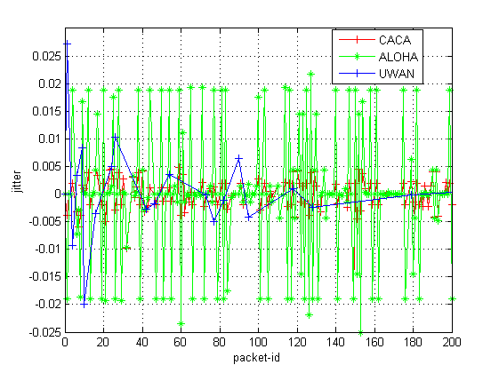
Figure 9 The packet-drop rate with the simulation time of 500
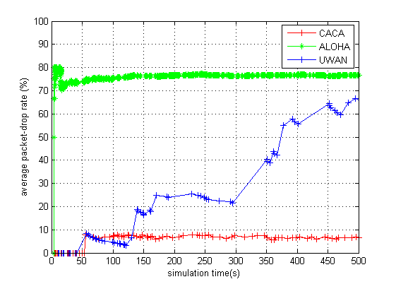
Figure 10 The packet-drop rate with the simulation time on different conditions
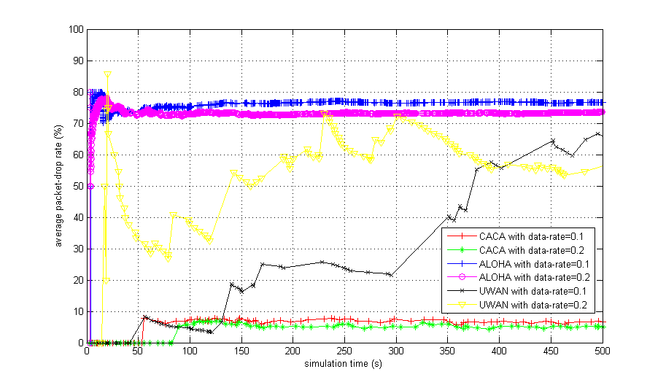
Figure 9, Figure 10 and Figure 11 shows the Dropped Packet Ratio (DPR) under different conditions. It can be seen that the DRP of the CACA-UAN is lower than the other protocols in Figure 9 and the Figure 10. Figure 11 illustrates the DPR changes of the three protocols through 10 simulations tests, where the CACA-UAN and ALOHA are more stable than UWAN, although the ALOHA maintains higher DPR during the ten tests.
Figure 11 The packet-drop rate with the number of the simulation runs
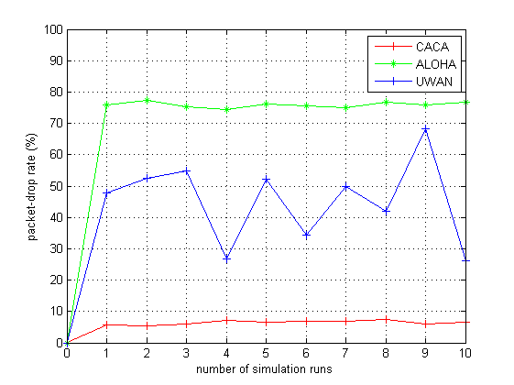
According to the experiment results, the CACA-UAN has shown better efficiency and reliability of the underwater network compared to other similar protocols. When context information is applied to the communication system, low collision probability and dropped packet ratio, as well as smoother jitter patterns can be achieved due to rational arrangement of communication and packet transmission.
5 Conclusion and Future Work
In this paper, the CACA-UAN is proposed which consists of a context-aware approach to an underwater acoustic network, a communication model, a scheme for context-aware device association and a context-aware communication mechanism to improve the overall performance of the underwater communication system. According to the simulation results, the improvement of performance of the underwater communication system is proved in terms of the delay, jitter and packet-drop rate. It also indicates that the context-aware approach can enhance the performance of the communication system and have a broad prospect in the design of the underwater communication system.
In the future, existing MAC schemes for underwater acoustic sensor networks will be investigated, whereas the implementation of a novel context-aware MAC protocol is undertaken to improve the underwater acoustic communication.
Acknowledgement
This work is supported by the NSFC (61300238, 61300237, 61232016, 1405254, 61373133), Marie Curie Fellowship (701697-CAR-MSCA-IFEF-ST), Basic Research Programs (Natural Science Foundation) of Jiangsu Province (BK20131004) and the PAPD fund.
References
Abowd, G.D., Dey, A.K., Brown, P. J., Davies, N., Smith, M. and Steggles, P. (1999) ‘Towards a Better Understanding of Context and Context-Awareness’, Proceedings of the 1st international symposium on Handheld and Ubiquitous Computing, pp. 304-307.
Al-Bzoor, M., Zhu, Y-B., Liu, J., Ammar, R., Cui, J-H. and Rajasekaran, S. (2015) ‘An adaptive power controlled routing protocol for underwater sensor network’, International Journal of Sensor Networks, Vol. 18, No. 3/4, pp. 238-249.
An, W., Lin, J., Luo, H. and Ci, S. (2013) ‘Significance-based energy-efficient path selection for multi-source underwater sensor networks’, International Journal of Sensor Networks, Vol. 13, No. 1, pp. 30-43.
Chen, K-C., Ma, M-D., Cheng, E., Yuan, F. and Su, W. (2014) ‘A Survey on MAC Protocols for Underwater Wireless Sensor Networks’, IEEE Communications Surveys & Tutorials, Vol. 16, No. 3, pp. 1433-1447.
Choi, M. J., Torralba, A. and Willsky, A. S. (2012) ‘A Tree-Based Context Model for Object Recognition’, IEEE Transactions on Pattern Analysis and Machine Intelligence, Vol. 34, No. 2, pp. 240-252.
Dol, H. S., Colin, M. E. G. D., Ainslie, M. A. A., Walree, P. A.V. and Janmaat, J. (2013) ‘Simulation of an Underwater Acoustic Communication Channel Characterized by Wind-Generated Surface Waves and Bubbles’, IEEE Journal of Oceanic Engineering, Vol. 38, No. 4, pp. 642-654.
Ebihara , T. and Mizutani , K. (2014) ‘Underwater Acoustic Communication With an Orthogonal Signal Division Multiplexing Scheme in Doubly Spread Channels’, IEEE Journal of Oceanic Engineering, Vol. 39, No. 1, pp. 47-58.
Fanelli, M., Foschini, L., Corradi, A. and Boukerche, A. (2013) ‘Self-Adaptive Context Data Distribution with Quality Guarantees in Mobile P2P Networks’, IEEE Journal on Selected Areas in Communications, Vol. 31, No. 9, pp. 115-131.
Gibson, J. H., Xie, G. G., Xiao, Y. and Chen, H. (2007) ‘Analyzing the Performance of Multi-hop Underwater Acoustic Sensor Networks’, IEEE/OES Oceans 07 Aberdeen Conference.
Guo, P., Wang, J., Li, B. and Lee, S-Y. (2014) ‘A Variable Threshold-value Authentication Architecture for Wireless Mesh Networks’, Journal of Internet Technology, Vol. 15, No. 6, pp. 929-936.
Han, G-J., Jiang, J-F., Bao, N., Wan, L-T. and Guizani, M. (2015) ‘Routing protocols for underwater wireless sensor networks’, IEEE Communications Magazine, Vol. 53, No. 11, pp. 72-78.
Han, S. N., Lee, G. M. and Crespi, N. (2014) ‘Semantic Context-Aware Service Composition for Building Automation System’, IEEE Transactions on Industrial Informatics, Vol. 10, No. 1, pp. 752-761.
Han, X-G., Wei, W., Miao, C-Y., Mei, J-P. and Song, H-J. (2014) ‘Context-Aware Personal Information Retrieval from Multiple Social Networks’, IEEE Computational Intelligence Magazine, Vol. 9, No. 2, pp. 18-28.
Hu, F., Malkawi, Y., Kumar, S. and Xiao, Y. (2008) ‘Vertical and Horizontal Synchronization Services with Outlier Detection in Underwater Sensor Networks’, Wireless Communications and Mobile Computing (WCMC), Vol. 8, No. 9, pp. 1165-1181.
Hu, P., Tilghman, P., Malkawi, Y. and Xiao, Y. (2007) ‘A Prototype Underwater Acoustic Sensor Network Platform with Topology-aware MAC Scheme’, International Journal of Sensor Networks (IJSNet), Vol. 2, No. 5/6, pp. 386-398.
Huang, Y., Liang, W., Yu, H-B. and Xiao, Y. (2008) ‘Target Tracking Based on a Distributed Particle Filter in Underwater Sensor Networks’, Wireless Communications and Mobile Computing (WCMC), Vol. 8, No. 8, pp. 1011-1022.
Iturri, P. L., Azpilicueta, L., Astrain, J. J., Aguirre, E., Salinero, E., Villadangos, J. and Falcone, F. (2016) ‘Implementation of Wireless Sensor Network Architecture for Interactive Shopping Carts to Enable Context-Aware Commercial Areas’, IEEE Sensors Journal, Vol. 16, No. 13, pp. 5416-5425.
Kantarci, M. E., Mouftah, H. T. and Oktug, S. (2011) ‘A Survey of Architectures and Localization Techniques for Underwater Acoustic Sensor Networks’, IEEE Communications Surveys & Tutorials, Vol. 13, No. 3, pp. 482-502.
Kaushal, H. and Kaddoum, G. (2016) ‘Underwater Optical Wireless Communication’, IEEE Access, Vol. 4, pp. 1518-1547.
Kwak, K., Park, D., Chung, W. K. and Kim, J. (2016) ‘Underwater 3-D Spatial Attenuation Characteristics of Electromagnetic Waves with Omnidirectional Antenna’, IEEE/ASME Transactions on Mechatronics, Vol. 21, No. 3, pp. 1409-1419.
Li, C., Xu, Y-J., Diao, B-Y., Wang, Q. and An, Z-L. (2016) ‘DBR-MAC: A Depth-Based Routing Aware MAC Protocol for Data Collection in Underwater Acoustic Sensor Networks’, IEEE Sensors Journal, Vol. 16, No. 10, pp. 3904-3913.
Li, Q., Li, H-K., Russell, P., Chen, Z. and Wang, C-G. (2014) ‘CA-P2P: Context-Aware Proximity-Based Peer-to-Peer Wireless Communications’, IEEE Communications Magazine, Vol. 52, No. 6, pp. 32-41.
Liu, B., Yan, Z-S. and Chen, C-W. (2013) ‘MAC Protocol in Wireless Body Networks for E-Health: Challenges and a Context Aware Design’, IEEE Wireless Communications, Vol. 20, No. 4, pp. 64-72.
Luo, Y., Pu, L., Zuba, M., Peng, Z. and Cui, J-H. (2014) ‘Challenges and Opportunities of Underwater Cognitive Acoustic Networks’, IEEE Transactions on Emerging Topics in Computing, Vol. 2, No. 2, pp. 198-211.
Mandal, P. and De, S. (2015) ‘New Reservation Multiaccess Protocols for Underwater Wireless Ad Hoc Sensor Networks’, IEEE Journal of Oceanic Engineering, Vol. 40, No. 2, pp. 277-291.
Miotto, R. and Lanckriet, G. (2012) ‘A Generative Context Model for Semantic Music Annotation and Retrieval’, IEEE Transactions on Audio, Speech, and Language Processing, Vol. 20, No. 4, pp. 1096-1108.
Misra, S., Das, S. N. and Obaidat, M.S. (2014) ‘Context-Aware Quality of Service in Wireless Sensor Networks’, IEEE Communications Magazine, Vol. 52, No. 6, pp. 16-23.
Molins, M. and Stojanovic, M. (2006) ‘Slotted FAMA: a MAC Protocol for Underwater Acoustic Networks’, Proceedings of MTS/IEEE OCEANS, Boston, pp. 1-7.
Noh, Y., Lee, U., Han, S., Wang, P., Torres, D., Kim, J. and Gerla, M. (2014) ‘DOTS: A Propagation Delay-Aware Opportunistic MAC Protocol for Mobile Underwater Networks’, IEEE Transactions on Mobile Computing, Vol. 13, No. 4, pp. 766-782.
Ojha , T., Khatua , M. and Misra , S. (2013) ‘Tic-Tac-Toe-Arch: a self-organising virtual architecture for Underwater Sensor Networks’, IET Wireless Sensor Systems, Vol. 3, No. 4, pp. 307-316.
Pompili, D., Melodia, T. and Akyildiz, I.F. (2009) ‘A CDMA-Based Medium Access Control for Underwater Acoustic Sensor Networks’, IEEE Transactions on Wireless Communications, Vol. 8, No.4, pp. 1899-1909.
Prabha, C., Ananthakrishnan, V., Supriya, M. H. and Pillai, P. R. S. (2013) ‘Localisation of underwater targets using sensor networks’, International Journal of Sensor Networks, Vol. 13, No. 3, pp. 185-196.
Qarabaqi, P. and Stojanovic, M. (2013) ‘Statistical Characterization and Computationally Efficient Modeling of a Class of Underwater Acoustic Communication Channels’, IEEE Journal of Oceanic Engineering, Vol. 38, No. 4, pp. 701-717.
Qu, F-Z., Wang, S-Y., Wu, Z-H. and Liu, Z-B. (2016) ‘A survey of ranging algorithms and localization schemes in underwater acoustic sensor network’, China Communications, Vol. 13, No. 3, pp. 66-81.
Roussaki, I., Kalatzis, N., Liampotis, N., Kosmides, P., Anagnostou, M., Doolin, K., Jennings, E., Bouloudis, Y. and Xynogalas, S. (2012) ‘Context-awareness in wireless and mobile computing revisited to embrace social networking’, IEEE Communications Magazine, Vol. 50, No. 6, pp. 74-81.
Schilit, B.N., Adams, N. and Want, R. (1994) ‘Context-Aware Computing Applications’, Proceedings of IEEE Workshop on Mobile Computing Systems and Applications (WMCSA'94), pp. 85-90.
Semiari, O., Saad, W., Valentin, S., Bennis, M. and Poor, H. V. (2015) ‘Context-Aware Small Cell Networks: How Social Metrics Improve Wireless Resource Allocation’, IEEE Transactions on Wireless Communications, Vol. 14, No. 11, pp. 5927-5940.
Shen, J., Tan, H-W., Wang, J., Wang, J-W. and Lee, S-Y. (2015) ‘A Novel Routing Protocol Providing Good Transmission Reliability in Underwater Sensor Networks’, Journal of Internet Technology, Vol. 16, No. 1, pp. 171-178.
Simpson, J. A., Hughes, B. L. and Muth, J. F. (2012) ‘Smart Transmitters and Receivers for Underwater Free-Space Optical Communication’, IEEE Journal on Selected Areas in Communications, Vol. 30, No. 5, pp. 964-974.
Tang, S-J., Dong, Y-H. and Zhang, X-D. (2014) ‘Impulse Response Modeling for Underwater Wireless Optical Communication Links’, IEEE Transactions on Communications, Vol. 62, No. 1, pp. 226-234.
Walree, P. A.V. and Otnes, R. (2013) ‘Ultrawideband Underwater Acoustic Communication Channels’, IEEE Journal of Oceanic Engineering, Vol. 38, No. 4, pp. 678-688.
Wang, H-L., Yang, K-D. and Zheng, K. (2015) ‘Performance of Dipole Antenna in Underwater Wireless Sensor Communication’, IEEE Sensors Journal, Vol. 15, No. 11, pp. 6354-6359.
Wang, P., Zhang, L. and Li, V. O. K. (2013) ‘Asynchronous cooperative transmission for three-dimensional underwater acoustic networks’, IET Communications, Vol. 7, No. 4, pp. 286-294.
Xiao, Y., Peng, M., Gibson, J., Xie, G. G., Du, D-Z. and Vasilakos, A. V. (2012) ‘Tight Performance Bounds of Multihop Fair Access for MAC Protocols in Wireless Sensor Networks and Underwater Sensor Networks’, IEEE Transactions on Mobile Computing, Vol. 11, No. 10, pp. 1538-1554.
Xiao, Y., Zhang, Y-P., Gibson, J. H., Xie, G. G. and Chen, H. (2011) ‘Performance Analysis of Aloha and p-persistent Aloha for Multi-hop Underwater Acoustic Sensor Networks’, Cluster Computing, Springer, Vol. 14, No. 1, pp. 65-80.
Xie, P., Zhou, Z., Peng, Z., Yan, H., Hu, T-S., Cui, J-H., Shi, Z-J., Fei, Y-S. and Zhou, S-L. (2009) ‘Aqua-Sim: An NS-2 based simulator for underwater sensor networks’, Proceedings of OCEANS 2009, pp. 1-7.
Xie, S-D. and Wang, Y-X. (2014) ‘Construction of Tree Network with Limited Delivery Latency in Homogeneous Wireless Sensor Networks’, Wireless Personal Communications, Vol. 78, No. 1, pp. 231-246.
Zhang, X-G., Liu, H-B. and Abraham, A. (2013) ‘A Novel Process Network Model for Interacting Context-Aware Web Services’, IEEE Transactions on Services Computing, Vol. 6, No. 3, pp. 344-357.
Zhang, Y-Z., Chen, Y-G., Zhou, S-L., Xu, X-M., Shen, X-H. and Wang, H-Y. (2016) ‘Dynamic Node Cooperation in an Underwater Data Collection Network’, IEEE Sensors Journal, Vol. 16, No. 11, pp. 4127-4136.

