The need for improved Spontaneous Coronary Artery Dissection (SCAD) care
Natalie Elliott¹, Alice Pearsons¹, Coral Hanson¹ and Lis Neubeck^{1,2}
- Centre for Cardiovascular Health, Edinburgh Napier University, Sighthill Court, EH11 4BN, Edinburgh
- Sydney Nursing School, Charles Perkins Centre, Johns Hopkins Road, University of Sydney, Sydney, NSW 2006, Australia
Correspondence to: Alice Pearsons; a.pearsons@napier.ac.uk

What is SCAD?
Spontaneous Coronary Artery Dissection (SCAD) is an increasingly acknowledged cause of acute coronary syndrome (ACS) in younger women (Saw et al. 2016). Approximately 4% of ACS can be attributed to SCAD, 87-95% of whom are female (Hayes et al. 2020) and 22%-35% of survivors are women ≤ 60 years (Saw et al. 2017). SCAD is an acute coronary event where a haematoma forms within the tunica media causing spontaneous separation from the coronary artery wall. This compresses the lumen, causing ischaemia and myocardial infarction (MI) (Hayes et al. 2020). It is distinct from atherosclerotic disease (Saw et al. 2016).
Typically, SCAD patients have few traditional cardiovascular risk factors. However, female sex hormones, hormonal fluctuations, underlying artery disease, genetics, and environmental, physical, and emotional events have been implicated in the development of SCAD (Hayes et al. 2020). It has also been associated with fibromuscular dysplasia (FMD), a condition that causes arterial walls to become more rigid and subject to stenosis, aneurysm, and dissection (Pappaccogli et al. 2021). SCAD recovery is complex, and individuals report high levels of psychological distress, including depression, anxiety, and post-traumatic stress disorder (Johnson et al. 2020a). Increasing recognition of SCAD has resulted in a 30% increase in SCAD diagnoses in the last decade. However, there remains a need to enhance awareness of the signs and symptoms to improve accurate identification of SCAD as the underlying aitiology of MI. Continued research is needed to address gaps in the mechanistic causes of SCAD, diagnostic techniques, quantification of risk and best management to improve outcomes (Hayes et al. 2018).

What is known about SCAD?
Acute management of SCAD should be conservative (Adlam et al. 2018; Hayes et al. 2020; Saw 2020). This involves medical therapy, including beta-blockers and antiplatelet agents, to control symptoms and allow for spontaneous healing. Percutaneous coronary intervention (PCI) should generally be avoided due to its increased risk of coronary complications (Adlam et al. 2018). Patients should be screened for FMD, connective tissue disorders, and genomic testing is advised (Hayes et al. 2020; Maas et al. 2019). Specialist diagnostics in the form of intracoronary imaging or magnetic resonance imaging may be necessary (Adlam et al. 2018; Saw 2020). Post SCAD chest pain is common; however, the aetiology of this is currently unknown (Waterbury et al. 2018). As SCAD predominately affects women there is also a need to provide advice on contraception, pregnancy and the menopause (Adlam et al. 2018).
There is strong evidence that cardiac rehabilitation (CR) post-MI reduces cardiac events and decreases mortality, but current evidence has been generated in male, older populations with atherosclerotic disease (Anderson et al. 2016). SCAD patients have different CR requirements as current education is aimed at those with atherosclerotic disease, and it is unclear whether CR exercise guidelines are appropriate for SCAD survivors (Edwards et al. 2019). Women who survive SCAD need specialist exercise recommendations and support from those who understand their condition (Adlam et al. 2018). Female SCAD patients may also require menopause and hormonal counselling as chest pain is greatly influenced by the hormonal fluctuations of perimenopause and menopause (Tweet Marysia et al. 2017). This support is not always currently available.
Inadequate management recommendations and lack of secondary prevention options may contribute to the observed higher levels of distress, reduced quality of life scores and readmission to hospital with cardiac events for SCAD survivors (Bouchard et al. 2020; Chou et al. 2016; Hayes et al. 2020; Johnson et al. 2020b). Therefore, SCAD recovery programmes are required that offer psychosocial support, and exercise support to reduce fear and hesitancy that may lead to physical activity avoidance (Johnson et al. 2020b; Saw et al. 2019). Hayes et al (2018) also highlight the need for personalised risk assessment and management plans for SCAD patients.

What services do SCAD patients require?
There is currently a lack of expertise and knowledge among healthcare professionals, leading to missed diagnoses and inadequate treatment (Binnie et al. 2023). A specialist SCAD clinic can provide patients with non-atherosclerotic medication management, access or referral to exercise advice, psychological counselling / support, menopause advice, genomic testing, pregnancy and contraception advice, and head to hip imaging to screen for any other vascular abnormalities as appropriate. Furthermore, specialised clinics can serve as hubs for collecting comprehensive data on SCAD patients, facilitating research efforts to better understand the condition's aetiology, risk factors, and long-term outcomes (Saw et al. 2016; Saw et al. 2019) (figure 1).
Currently, there is one specialist SCAD clinic in the UK, based in Leicester. However, this service is fragile due to single clinician services being vulnerable to external pressures. Additionally, not all trusts or health boards will fund patient referral when MI management can be provided locally, despite SCAD patients requiring specialist help. A further challenge is that patients need to self-fund their own travel and accommodation. Consequently, new services are being developed in Scotland and London which should alleviate some of the burden of travel for patients and provide a more robust clinical service.
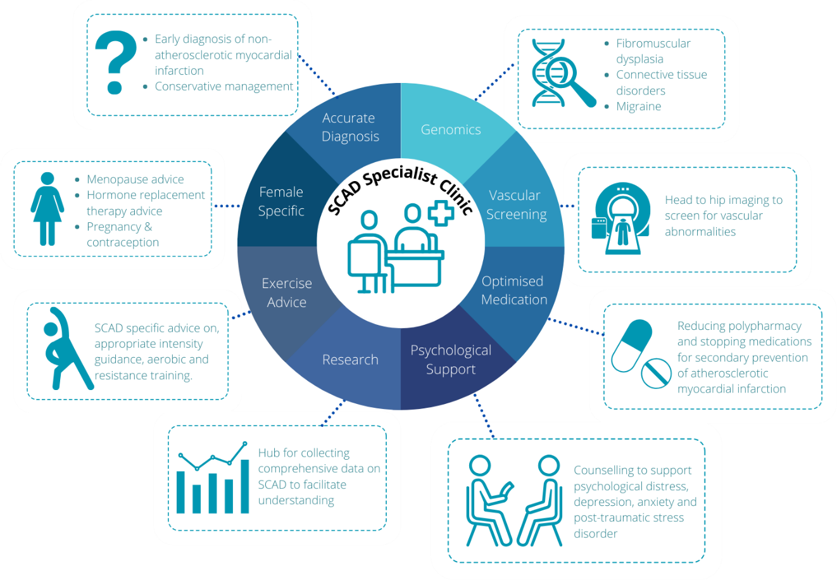
Figure 1. SCAD specialist clinic
Cardiac rehabilitation programmes should play a significant role in SCAD patient recovery (Bouchard et al. 2021). However, current CR delivery must be better aligned to SCAD patients’ needs. Further research is required to develop SCAD appropriate exercise guidelines, and to codesign and test tailored recovery support interventions that address physical and mental wellbeing (Binnie et al. 2023; Bouchard et al. 2021; Neubeck et al. 2022). The relatively low incidence of SCAD means that remotely delivered digital interventions are likely to serve this disparate patient population. Additionally, healthcare provider-facilitated peer-support programs or group counselling may offer significant benefits (Bouchard et al. 2021).

What do patients say?
The patient narrative should shape the evolution of SCAD services (Hayes et al. 2020). Patient co-design serves as a crucial source of experiential knowledge, shedding light on unique symptoms, recovery challenges, and the psychological impact patients face. Incorporating patient perspectives ensures patient-centred care, aligning healthcare strategies with actual needs and enhancing treatment adherence. This ultimately improves outcomes, creating effective and compassionate SCAD services. Here are the experiences of three women (table 1).
Table 1. SCAD Survivor Narratives:
Patient 1 | “I find my GP doesn’t really know what to do about this, I was recently advised to stop one of these meds due to oedema in my feet and when I questioned this given my BP was already high and given my history she said "well it’s just a trial". I didn't change my meds. I ask questions if I'm worried such as a recent odd bout of indigestion which lasted a week and I approached my pharmacist for advice, again, he hadn’t heard of SCAD and was initially quite condescending however when I explained he said to see GP if it didn't resolve with meds in 24hrs. The lasting impact is mainly on my mental health in that I will immediately question incidences like these instead of handling them as their unique situations in the way I would have in the past.”
Patient 2 | “I recently bought a Medical Emergency bag that goes everywhere with me.  I am absolutely fine but….. If I am somewhere on my own, where people do not know me, I still worry about what may happen.”
Patient 3 | “I’m fortunate that the local health board part funds trips to Leicester - although the last 4 appointments have been via telephone - so not needed.  However, there is still substantial outlay to travel - especially as I don’t work. I rather have a face-to-face, but economically I couldn’t manage - even with part funded expenses.”

Conclusion
Persistent challenges in managing SCAD include the need for immediate, accurate diagnosis to enhance patient outcomes. There is also a demand for heightened healthcare expertise to reduce misdiagnoses and improve SCAD survivor treatment options. A lack of clear recommendations for physical activity, family planning, and genetic assessment, and the dearth of substantial, high-quality evidence for both immediate and prolonged management further contribute to the complex landscape. Therefore, development of new specialist SCAD services is the first step to mitigating these uncertainties for SCAD survivors in a person-centred way.

References
Adlam D, Alfonso F, Maas A, Vrints C, Writing C. 2018. European society of cardiology, acute cardiovascular care association, SCAD study group: A position paper on spontaneous coronary artery dissection. Eur Heart J. 39(36): 3353-3368.
Anderson L, Thompson DR, Oldridge N, Zwisler AD, Rees K, Martin N, Taylor RS. 2016. Exercise-based cardiac rehabilitation for coronary heart disease. Cochrane Database Syst Rev. 2016(1): Cd001800.
Binnie K, Neubeck L, McHale S, Hanson CL. 2023. What do spontaneous coronary artery dissection survivors want to support their recovery? A qualitative study. Euro J Cardiovasc Nurs. zvad013.
Bouchard K, Coutinho T, Reed J, Lalande K, Tarannum CN, So D, Saw J, Mulvagh S, Tulloch H. 2021. Recovering from spontaneous coronary artery dissection: Patient-reported challenges and rehabilitative intervention needs. Health Psychol. 40(7): 472-479.
Bouchard K, Tarannum CN, Coutinho T, So D, Tulloch H. 2020. Secondary preventative care for patients after spontaneous coronary artery dissection: A qualitative analysis of health care providers’ perspectives. Can J Cardiol. 36(7): 1156-1160.
Chou AY, Prakash R, Rajala J, Birnie T, Isserow S, Taylor CM, Ignaszewski A, Chan S, Starovoytov A, Saw J. 2016. The first dedicated cardiac rehabilitation program for patients with spontaneous coronary artery dissection: Description and initial results. Can J Cardiol. 32(4): 554-560.
Edwards KS, Hekler AC, Baum J, Nejedly M, Tsai S, Khandelwal A, Naderi S, Hoover V, Tremmel JA. 2019. Psychological distress among female cardiac patients presenting to a women's heart health clinic. Am J Cardiol. 123(12): 2026-2030.
Hayes SN, Kim ESH, Saw J, Adlam D, Arslanian-Engoren C, Economy KE, Ganesh SK, Gulati R, Lindsay ME, Mieres JH et al. 2018. Spontaneous coronary artery dissection: Current state of the science: A scientific statement from the american heart association. Circulation. 137(19): e523-e557.
Hayes SN, Tweet MS, Adlam D, Kim ESH, Gulati R, Price JE, Rose CH. 2020. Spontaneous coronary artery dissection: Jacc state-of-the-art review. J Am Coll Cardiol. 76(8): 961-984.
Johnson AK, Hayes SN, Sawchuk C, Johnson MP, Best PJ, Gulati R, Tweet MS. 2020a. Analysis of posttraumatic stress disorder, depression, anxiety, and resiliency within the unique population of spontaneous coronary artery dissection survivors. J Am Heart Assoc. 9(9): e014372.
Johnson AK, Hayes SN, Sawchuk C, Johnson MP, Best PJ, Gulati R, Tweet MS. 2020b. Analysis of posttraumatic stress disorder, depression, anxiety, and resiliency within the unique population of spontaneous coronary artery dissection survivors. J Am Heart Assoc. 9(9): e014372.
Maas AHEM, Bouatia-Naji N, Persu A, Adlam D. 2019. Spontaneous coronary artery dissections and fibromuscular dysplasia: Current insights on pathophysiology, sex and gender. Int J Cardiol. 286:220-225.
Neubeck L, McHale S, Ross M, MacGillivray S, Galbraith M, Hanson C. 2022. Spontaneous coronary artery dissection: A systematic review of physical and psychosocial recovery following discharge from hospital. Eur J Cardiovasc Nurs. 21(7): 665-676.
Pappaccogli M, Di Monaco S, Warchoł-Celińska E, Lorthioir A, Amar L, Aparicio LS, Beauloye C, Bruno RM, Chenu P, de Leeuw P et al. 2021. The european/international fibromuscular dysplasia registry and initiative (feiri)—clinical phenotypes and their predictors based on a cohort of 1000 patients. Cardiovasc Res. 117(3): 950-959.
Saw J. 2020. Is there a role for cardiac magnetic resonance imaging in patients with scad? Eur Heart J. 41(23): 2206-2208.
Saw J, Humphries K, Aymong E, Sedlak T, Prakash R, Starovoytov A, Mancini GBJ. 2017. Spontaneous coronary artery dissection: Clinical outcomes and risk of recurrence. J Am Coll Cardiol. 70(9): 1148-1158.
Saw J, Mancini GBJ, Humphries KH. 2016. Contemporary review on spontaneous coronary artery dissection. J Am Coll Cardiol. 68(3): 297-312.
Saw J, Starovoytov A, Humphries K, Sheth T, So D, Minhas K, Brass N, Lavoie A, Bishop H, Lavi S et al. 2019. Canadian spontaneous coronary artery dissection cohort study: In-hospital and 30-day outcomes. Eur Heart J. 40(15): 1188-1197.
Tweet Marysia S, Codsi E, Best Patricia JM, Gulati R, Rose Carl H, Hayes Sharonne N. 2017. Menstrual chest pain in women with history of spontaneous coronary artery dissection. J Am Coll Cardiol. 70(18): 2308-2309.
Waterbury TM, Tweet MS, Hayes SN, Eleid MF, Bell MR, Lerman A, Singh M, Best PJM, Lewis BR, Rihal CS et al. 2018. Early natural history of spontaneous coronary artery dissection. Circ Cardiovasc Interv. 11(9):e006772.

