A Reflective Case Study on using Team Academy principles to integrate a university-based business incubator service into the mainstream curriculum

Dr Wendy Wu
Edinburgh Napier University (UK)
w.wu2@napier.ac.uk
Dr Hock Tan
Edinburgh Napier University (UK)
h.tan@napier.ac.uk
Dr Pauline Miller Judd
Edinburgh Napier University (UK)
p.millerjudd@napier.ac.uk
Abstract
The fast-changing world requires graduates equipped with the entrepreneurial skills necessary to solve real-world challenges. University based business incubators have largely been regarded as production units for new businesses and existing academic research has focused on this rather than their potential in the field of university education. It is the intention of this case study to address the latter area from the perspective of the pedagogical challenges of entrepreneurship education.
The case study explores the potential of business incubators as an entrepreneurship pedagogical tool and focuses on the busines incubator at Edinburgh Napier University, a modern UK university. The study provides a critical reflection on a series of experiments on how team academy principles have been applied in a business incubator with a view to integrating ‘being’, ‘knowing’ ‘doing’ and ‘creating’ into mainstream curriculum. The case study provides new insights for universities on how best utilise business incubators as a catalyst for new knowledge creation.
Key words:
Innovative Learning, Learning Integration, ‘Knowing, Being, Doing and Creating’, Team Academy, New Knowledge Creation

A Reflective Case Study on using Team Academy principles to integrate a university-based business incubator service into the mainstream curriculum
Introduction:
According to the QAA (2018, p. 7), enterprise is “the generation and application of ideas, which are set within practical situations during a project or undertaking”. In 2017, Edinburgh Napier University, a modern university with approximately 18,000 students, developed an Innovation and Enterprise Strategy (Miller Judd & Laing, 2017) focused on enhancing enterprise activities both within the formal curriculum and as extracurricular activities. Building on this strategy, this pilot project sought to explore ways that the university’s incubation hub could work with academic staff on projects embedded in the formal Business School curriculum.
Bright Red Triangle (BRT) is the hub for innovation and enterprise practice at Edinburgh Napier University which supports staff, students, and alumni to develop enterprise skills and capture business opportunities. BRT has followed traditional models of University incubators, supporting student and graduate entrepreneurs as well as research and development. This support is provided through business advice, both specific advice provided on a one-to-one basis and more generic advice provided in workshops and online activities. BRT engages with entrepreneurial activities and helps bridge the gaps between the university education and real-world business.
BRT grew out of Edinburgh Napier Business School (ENBS), scaling up its service to provide support to all six schools in the university. Given its root and originality from ENBS, the natural connection provides a culture ground for developing new initiatives. The appointment of a New Dean in 2018 reshaped the ENBS strategy to focus on ‘empowerment, enterprise and employability’ for all. The strategy has not only become the base for a change in management but also to position ENBS in the heart of the industry and society.
The aim of this chapter is to reflect on lessons learned during this 3-year pilot project focusing on student and staff learning and the micro embedding of team academy principles in joint enterprise projects.
Why and how the journey started:
Through observation, reflection and informal feedback concerning teaching activities and business advising, several enterprise service gaps were identified:
a) Reviewing students’ business plans showed their understanding of business lacked depth. Overseas students interested in a Tier 1 graduate visas require innovative and viable business plans and those submitted often demonstrated superficial understanding of business and a lack of ability to apply conceptual ideas to real-world situations.
b) Some academic colleagues were using dated theoretical case studies and lacked the channels to approach guest speakers from business to enhance the real-world learning experience of students.
c) Students either realised the value of incubator activities late in their studies or struggled to find the time to engage with BRT activities. BRT often struggled to get sufficient attendees to participate in their practice-oriented workshops, with student attendance being disappointing and/or sporadic.
d) Also, there were perceived gaps in curriculum and support for social enterprise. Students appeared less informed of the real-world practices of social innovation movements such as climate change, global citizenship, and equality. This highlighted that the pace of theoretical knowledge development did not match the real-world needs and reflects Billett’s (2010) assertions that higher education’s emphasis on educational provision privileges more traditional learning.
Students are increasingly restricted with time to balance work, social life, study, and the extra-curricular nature of the business incubator services was identified as a restriction to student utilisation. Stuart et al., noted that “differences in ECA (extra-curricular activity) engagement are evident between ‘traditional’ and what may be defined more widely as ‘widening participation/non-traditional’ students” (2011: 212). As Edinburgh Napier University has a large proportion of non-traditional students, these challenges with extracurricular engagement highlighted that the development of embedded ‘real-world’ learning could enhance learning outcomes, expand opportunities for students to engage with start-up businesses and ultimately increase the success of both BRT and student outcomes.
Consideration was given to constructing a model which allowed students to participate in experiential learning, through which they could discover their passions, understand how new knowledge is constructed, and use creativity to develop innovative solutions. This model created an open learning environment where students could apply theory through critical review and interaction with business/industry expertise, challenge status quos, challenge themselves and recognise how to lead their self-learning process.
Contemplating those changes led to exploration of two approaches namely Team Academy (TA) principles and Open Innovation (Chesbrough et al 2006). The Team Academy approach is based on learning by doing, working with customers, peer learning and applying theory to practice (Halttunen, 2006). In open innovation, Chesbrough et al. (2006) highlight that to gain a competitive advantage, organisations ought to create a knowledge flow to allow outsiders in and insiders out. These approaches highlighted that a business incubator could be the catalyst for such knowledge flow between the formal and informal learning opportunities. As such, embedding elements of BRT in the Business School curriculum was identified as a potential solution to the service gaps identified, addressing the challenges many students had to engage with BRT and place their academic learning in the context of real-world challenges.
To enable this, BRT business adviser (author Wu) and academic lecturer (author Tan) agreed to explore a collaboration to develop an integrated co-creation framework leading to a 3-year pilot project.
Developing the Project:
The trajectory of the project was in 3 stages:
- Dive in
- In-project learning and development by doing
- Championing for mainstreaming.
Two Business School undergraduate modules were selected for engagement with the pilot: “Business Strategy and Sustainable Development”, a final year module, and “Introduction to Business Ethics and Sustainability”, a second year module.
Project learning objectives were aligned with the UN SDG17 from which six key aligned areas were identified:
- Digital innovation and developing capacity for and within local communities
- Challenges of climate change including energy, consumption, and climate change impacts
- Gender equality and female empowerment
- Social capital and inequality
- Social investment models
- Community lending banks
Targeting these areas, selected thought leaders were invited to brief students on real world practice and challenges. Students were then assigned into groups according to how their interests aligned and student groups had the opportunity to develop professional working relationships with the thought leaders.
Three levels of possible student outputs were anticipated:
- A reflective piece of work. This could be either used for personal development or used towards summative assessments in their module.
- A consultancy output. At the time this was not possible to be assessed within either associated module. However, it helped bridge the gap between curriculum and incubator support.
- For those who developed a desire to engage with more entrepreneurial activities, they could go to BRT to discuss setting up their own business based on their learning from the challenge.
Year 1: Dive In
Given constraints of time, resources, and limited ability to change existing programme structures, the project team adopted a micro implementation of the Team Academy methodology by primarily using ‘learning by doing’ and enhancing ‘human relationships’, embedding constructive dialogue but not coaching. Students were briefed and introduced to the Isaacs’ dialogue model at the outset (Isaacs, 1999) to develop empathic listening and engagement to support the exploration of diverse perspectives from different stakeholders.
The project was designed for students to participate voluntarily though their modules. Initially it was anticipated there might be 100 students but only 24 signed up. Students were expected to sign up in groups according to their shared interests, but the numbers posed challenges given the levels of knowledge diversity. The original plan to be a competitive enterprise with the best team awarded a prize at the end of the session was dropped due to numbers and inequalities across the teams.
After the students engaged in immediate learning, observation and reflection, the activity shifted to a career-oriented talk from a social enterprise leader. This change was driven by students’ interests and desire to understand what inspired them and why they had given up a corporate role to run a social enterprise. Students found this level of engagement stimulating and it highlighted the need to understand the job market and engage with industry professionals to gain relevant employability skills.
Abandoning the original plan and diving in with the ‘live discussion’ was possible because of the trust established between the two project collaborators. This demonstrated the importance of flexibility and improvisation to enhance and maximise the learning experience. The project collaborators witnessed the power of learner determined learning and the benefits of learners driving the learning agendas. On reflection, this shows the benefit of facilitators themselves approaching tasks with an open mind and being willing to continually engage in exploration and learning. With that mindset there were learning opportunities for “teachers”, “students” and “speakers” before, during, and after the session. The receptive mindset also created an open and trusting environment in which students and participants took ownership of their own learning journey, and where passion and curiosity played an important role in new knowledge creation.
Unexpected Results:
The initial dive-in cultivated an environment for self-determined learning and authenticity of academic leadership emerged as an important enabler. Authenticity here refers to the importance for any professionals, including academic colleagues and external speakers, to bring their whole body of knowledge to the teaching and learning context.
There were three key take-aways from the first year. First, the project generated a significant workload for the staff involved, including project design, stakeholder engagement, recruitment, logistic liaison, project planning, execution, evaluation, and contingency development. However, it also provided interesting learning in understanding each other’s approaches and perspectives which provided a foundation to build the trust and validate the integration concept.
The second learning point was reflection on the root purpose of the project, highlighting the need to empower students and delegate tasks to them as the core of their learning and doing practice. This was further developed and implemented in year 2 of the experiment.
The third learning point was that the improvisational experience reinforced how important the focus on leaners’ needs is. The establishment of an environment where learning has been interacted and ‘negotiated’ with other learners and participants is vital in supporting those needs. It reinforced the idea that learning takes place in multiple levels of time and space and demonstrated the emergence of a virtual equal learning community where everyone has an equal footing and the teacher is merely a learning facilitator.
Beyond the anticipated outcomes of the year 1 pilot, a tangible output was generated through this collaboration. One graduate initiated a creative concept during the project which was awarded an Innovation Voucher from Interface. This enabled the graduate to test, validate, and prototype the idea in a chemistry material lab, working in collaboration with senior academic researchers from the School of Engineering and the Built Environment.
Year 2: In-project learning and development by doing
Reflecting on the learning from year 1, a framework was developed to keep the focus on team challenges but embedding ‘being, knowing, doing and creating’.

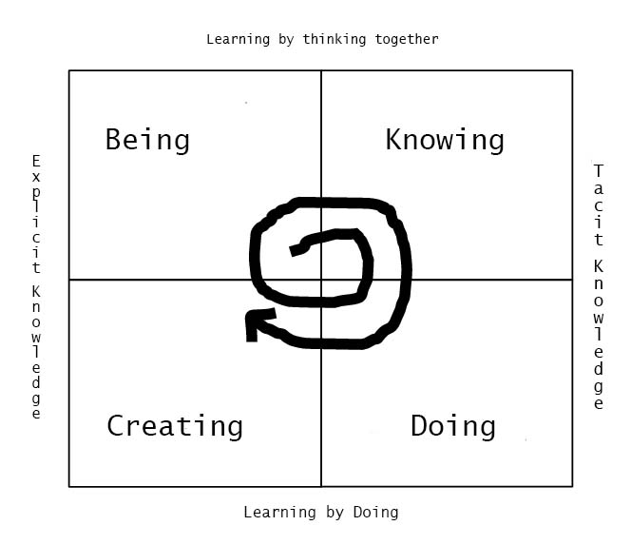
Figure 1. Four Domains of Knowledge Integration, Wu, Tan & Miller Judd, 2019
Building on the Team Academy learning model, based on Nonaka and Takeuchi’s knowledge management model, the framework was designed to integrate personal development (being) and business incubator service (doing and creating) into mainstream curriculum learning (knowing). These domains are achieved through the tackling of real-world challenges.
Being – students first need to explore their entrepreneurial passions and capacities by exploring their inner world to find what motivates them. This will determine which project they choose to work on.
Knowing – once students understand their own skillsets and passions, they are introduced to entrepreneurial thinking and processes, applying conceptual theories they have ‘learnt’ through traditional classroom-style learning.
Doing – here students get into small project groups and start immersing into themselves in real world challenges. This involves participating in the engagement conference and entering into debates with real world professionals. During this period, staff from the incubator deliver workshops on how to apply the knowledge they have to address real world challenges. Tool kits are provided to put into practice what they have learnt.
Creating – This is the final stage of synchronising knowledge and learning. Student groups are required to present their proposed solution in both a short written report and an oral presentation. They then take questions from other groups and teachers.
The tipping point for the project came when the collaborative facilitators invited the students to take on ownership of the project, including the learning design, organisation, and defining challenge activities and communication strategy. This led to a mini-conference being organised by the student teams, in which over 80 students engaged.
The learning engagement format was changed to motivate students to take their own initiative:
a) To provide a learning experience to make students realise that learning not only takes place in the classroom but also through engagement with the outside world.
b) To provide a showcase that enables students to understand how the civic society operates, enabling them to think about what role they can play in the community.
c) To inspire students to understand how social enterprises are built on the passion of entrepreneurs, how to leverage support from corporate sources to make a positive impact, and most importantly developing entrepreneurial skills to turn a challenge into an opportunity.
As a complementary activity, a learning expedition was organised by a staff member to a third sector organisation. Those students who engaged in the learning expedition found it a useful experience enabling them to engage with social entrepreneurs in their own environment.
Critical Reflection:
Reflection on year 2 suggested that empowering students to own the project provided a crucial change in manifesting the importance of engaging in self-directed learning, and establishing a learning environment which integrated passion, mission, profession, and vocation. However, it also posed a challenge in engaging stakeholders at multiple levels with the teaching and learning framework, as well as developing a quality assurance framework of integrating the four elements of ‘being’, ‘knowing’, ‘doing’ and ‘creating’.
The second iteration of the project highlighted resource challenges. Firstly, the timetabling of crucial activities was still challenging, and consideration needed to be given as to whether attendance was made compulsory. Also, students asked whether funds were available to test innovative ideas for their group projects but unfortunately, there were no financial resources available.
Accreditation and acknowledgement of student engagement was also highlighted as an issue. As with many higher education institutions, Edinburgh Napier is engaging with higher education achievement reports (HEAR). However, the issue is not only how to record the achievement and experience in the transcript, but also how to evaluate diverse participants’ engagement, experience, and quality assurance at each stage of development. It highlights the question to what extent non-academic engagement can be valued in a meaningful and validated manner.
Year 3: Championing for mainstreaming.
Consolidating the learning experience of the first 2 years, the year three experience made a significant leap. Early evidence of the project was presented to the Dean who was supportive of its development, and the project gained various championing bodies both in and outwith the university. In the third year it was decided this would remain a student led project enabling staff to move to a more supportive role. BRT services were also for the first time formally timetabled into the curriculum and there was a substantial increase in the number of students involved as the project became compulsory for final year students.
Students were invited to put themselves forward for leadership roles to support the conference which focused on ending poverty, the first goal of UN SDGs. Preceding the conference, three preparation workshops were organised for the students. The first one was on deep listening and dialogue, second on showcasing by social enterprises, and third on ideation. The conference was attended by over 250 delegates, of which 205 were students. As a result, in 2020, the project generated 65 student team projects with teams ranging from 3 to 5 participants. The teams were self-selecting and were given some staff support through the module leader and BRT. The nature of the projects they engaged with ranged from establishing instant ID cards for homeless people, to developing a computer application to connect institutional partners, and tracing relevant services for homeless people. BRT awarded the top three student projects support to continue their business development.
Additionally, elements of assessment were embedded in each stage of the project. Prior to the conference, students were asked to pitch and present a poster based on the use of business model canvas (source) to peer groups, which were assessed. At the conference poster exhibition, students were asked to practice their pitching skills to articulate their solutions for the issues and proposal for implementation. BRT and academic staff members jointly conducted the summative assessment. Moreover, a competition was organised, and the best three student teams were invited to pitch their ideas at the conference. Additionally, the top five ideas were invited to participate in an international entrepreneurial event co-hosted by BRT with the Strascheg Center for Entrepreneurship (SCE) at the Munich University of Applied Sciences (MUAS).
Challenges:
One of the biggest challenges was how to implement the TA principles within an existing structured course module. This requires the participants, including lecturers and speakers, to understand the basic concepts and TA principles holistically, ensuring its benefits can be maximised. TA principles were introduced to the module leaders through discussion on learning design, delivery, and evaluation. However, given the limited time, it was not possible to introduce TA fully to other participants prior to the sessions. Instead, the ethos and principles of TA was introduced by the module leaders throughout the sessions. This shared understanding took time to embed. It is only with the third iteration that the principles of learning by doing, working with customers, peer learning and applying theory to practice (Halttunen, 2006) were fully embedded. The nature of the project and the number of students involved meant that aspects of the TA approach, such as team coaching, were not possible.
TA principles were adapted to address the segmented issues with an intention to bring a holistic solution. However, to a certain degree, it was required to be de-holistic and broken down, as the TA methodology needed to fit the project’s purpose. Therefore, partial efforts only lead to partial results. To fully address the challenges facing universities, industry and societies, there is a need to draw the bigger picture together to shape a shared purpose, shared development agenda and the ownership of a shared journey and space together.
More explicitly, it means a University based incubator can play a stronger role in the new knowledge creation process within an existing curriculum, supporting not just ideation but also the development of production and services into the market space. The knowledge facilitation has also meant that more on-shelf academic knowledge can be better used for real world challenges. The knowledge flow needs to be created from an upward, and downward, inward, and outward spiral process involving individuals, teams, and the university as an organization.
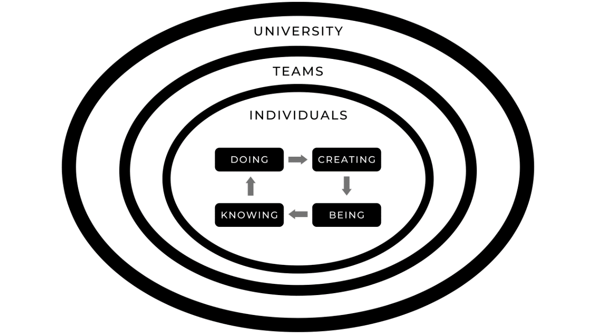
Figure 2. Knowledge Flow Spiral Process, Wu, Tan & Miller Judd, 2020
The importance of a coaching role and dialogue in these types of projects can never be underestimated. It can be utilised for the benefits of students, but also to develop the efficiency of the staff team. True dialogue can enhance their interaction, making it more productive which can lead to a transformative change. So far, TA approaches have only been applied in micro ways. Both Wu and Miller Judd are trained as Team Academy coaches and implemented TA principles in areas such as problem solving, real life learning, dialogue, and team learning. It is believed that if TA can be fully utilised, specifically to cultivate future change makers and future shapers, it will be for the benefit of the university and wider community. TA principles have inspired the project initiator (Wu) to influence other module leaders to implement a co-creating impactful curriculum through challenge-based learning and embed the university based incubator service in the mainstream curriculum. Part of the solution going forward might be using existing expertise to train academics to apply TA principles. By doing this, it is anticipated the range of outputs will proliferate and enhance a win-win situation for all stakeholders.
The embedding of this project in the curriculum happened quicker than expected, supported by the arrival of a new Dean of the Business School whose vision included bringing ‘empowerment, employment and entrepreneurship’ together. From multiple dimensions, the Dean was convinced of the value created by the project, seeing that it has contributed to a culture change at the Business School and created the possibility of a unique marketing proposition. Discussion is in progress with regards to how to scale up this co-creation model across the Business School curriculum. There are three fundamental challenges faced:
1. The need for designated resources if this model is to be applied across the whole curriculum. Given contextual differences, this requires a suitable mainstream model to be devised and adapted to suit individual modules.
2. Scaling up may require structural changes to the curriculum to allow for the flexibility and capacity to absorb emerging needs of students and learners, given the fluid nature of live projects.
3. Once the scale up model is determined, the approach to interaction and engagement with external stakeholders will need to be determined to maximise resources and impact.
Impact and Conclusion:
The project has had several impacts including:
- enhanced cultivation of students’ entrepreneurial development;
- embedded entrepreneurship into the mainstream curriculum and changed the learning environment;
- enhanced learning experience through integrating service provision and linking career, academic and personal development;
- a tangible outcome of a successful innovation voucher application supporting a graduate venture to partner with academic experts to develop a prototype of a new sustainable product.
The student feedback suggested that the TA approach of live real-world projects enhanced the quality-of-service provision as well as enriched the learning experience. The insights gained will feed into enhancing the entrepreneurial framework. Further testing and scale up will provide capacity to generate new knowledge particularly in how best to adapt the model to different situations.
Empowering students, peer-to-peer learning and cross-sector learning communities using TA principles has also helped develop student leadership and entrepreneurial abilities. The experiential learning has provided students with first-hand understanding of new knowledge creation, encouraging them to be active learners and giving them skills and confidence to tackle new problems. However, resource limitations have constrained the maximisation of learning outcomes and team coaching input could enhance outcomes for student teams.
One of the key learnings for staff members lies in how to cultivate entrepreneurship engagement and the integrated model has provided a starting point for enhanced integration both within and outwith the University. However, whilst BRT demonstrated how it can add value in an “academic” setting and act as an agent of change, the model needs to be further developed in different contexts and with different actors.
Three key takeaways from the project are:
- The project confirmed that creating a learning community and giving students ownership based on TA principles stimulates new knowledge, enhance the ownership of learning, and empower and engage students. This can create transformative change.
- The establishment of cross disciplinary/cross sector groups can add significant value to curriculum design, development, and delivery. Creating an integrated learning model, bringing academics, service professionals and experts from industry and business together can create a win-win situation enhancing knowledge transfer.
- If prepared to take risks and think innovatively, Higher Education institutions can develop new pedagogical strategies which help produce future ready graduates who are agile, adaptive, and resilient.

Reference List
Billett, S. (2010). The perils of confusing lifelong learning and lifelong education. International Journal of Lifelong Education, 29 (4), 401–413. https://doi.org/10.1080/02601370.2010.488803
Chesbrough, H. (2006). Open innovation: a new paradigm for understanding industrial innovation. Open innovation: Researching a new paradigm, 400, 0-19. https://www.researchgate.net/publication/232957368_Open_Innovation_Researching_A_New_Paradigm
Halttunen, J. (2006). Team Academy – award winning entrepreneurship education from Jyvaskyla, Finland, Presentation at OECD/IMHE Conference, Copenhagen, Denmark, 16 October 2006. http://www.oecd.org/education/imhe/37544053.pdf.
Isaacs, W. (1999). Dialogue and the Art of Thinking Together, New York: Currency, Doubleday Press
Miller Judd, P. & Laing, S. (2017). Innovation and Enterprise Strategy, Edinburgh Napier University, Online: available at: https://staff.napier.ac.uk/services/principal/strategy/Documents/Innovation%20and%20Enterprise%20Strategy.pdf.
OECD, www.oecd.org/education/imhe/37544053.pdf.
QAA, (2018). https://www.qaa.ac.uk/docs/qaas/enhancement-and-development/enterprise-and-entrpreneurship-education-2018.pdf?sfvrsn=15f1f981_8.
Stuart, M., Lido, C., Morgan, J. & May, S. (2011). The impact of engagement with extracurricular activities on the student experience and graduate outcomes for widening participation populations, Active Learning in Higher Education, 12(3), 203–215. https://doi.org/10.1177/1469787411415081
United Nations, https://www.un.org/sustainabledevelopment/sustainable-development-goals/.

Endnotes

Social enterprise is defined in a broader sense, referring to purpose-oriented businesses. It includes businesses in the third sector and beyond in the UK context.
The Innovation Voucher Scheme is a UK Government Initiative which provides up to £5000 of funding for academic assistance in the development of busines projects.
Algae Limited | Interface Knowledge Connection (interface-online.org.uk)

