Looking At Technology With Parkour Eyes

ACM copyright: ACM holds the copyright on the work.

Abstract

Tom Flint
Centre for Interaction Design
Edinburgh Napier University
Edinburgh UK EH10 5DT
t.flint@napier.ac.uk

Phil Turner
Centre for Interaction Design
Edinburgh Napier University
Edinburgh UK EH10 5DT
p.turner@napier.ac.uk

This workshop paper discusses the theme of repurposing and its relationship to appropriation. By centering on the social, cultural aspect of appropriation we link it to affordance through structuration theory. We argue that children view technology without preconceived cultural understandings. We then present an interactive piece that utilizes eyetracking software, designed to generate social interaction.

Author Keywords
Repurposing; appropriation; affordances; intention.

ACM Classification Keywords
H.5.2 User Interfaces

Introduction
Appropriation is often understood to mean using an artifact in a manner contrary to its designed purpose (repurposing). In the area of interaction, appropriation has become an increasingly important concept. The traditional view of the appropriation of computing technology has placed appropriation at the end of a process of adoption.
Much of the examination of the appropriation of technology has been centred on organisations, software or management information systems (De Sanctis & Poole 1994, Orlikowski 1992 and 2000; Stevens et al 2009). What these studies fail to tackle is the social collaborative and cultural practice of technology appropriation; demonstrated in our experiences, particularly with handheld devices (Bodker 2012).

Cultural Significance
Appropriation’s central role in culture has been highlighted in the recent battle between the Southbank in London and its skateboarders. Skateboarders first appropriated an unused space known as the undercroft in the mid 1970s. The historical antagonism between the authorities that run The Southbank and the skateboarders came to a head in 2013; when it was proposed that the area be turned into shops to fund a new extension.
The community that had appropriated the undercroft managed to organize submitting over 30,000 planning application objections (according to their website). There is now a legal case in the high court applying to grant the undercroft village green status and thereby perpetual legal protection. What is striking is that the highly motivated and organized political action came from young people, often portrayed in the press as disaffected and apathetic.
This situation concurs with the view that architecture is politicised, conforming to the needs of commodification and ownership (Debord 1967, Childress 2004, Borden 2001, Luis et al 2004). The language of architecture does not prescribe how the space is used but expectations of how it should be used (Childress 2004, Whyte 1988). Traceurs (those that practice parkour) claim to develop what are known as ‘parkour eyes’ (Ameel and Tani 2011.) This is an alternative perception of urban environments. They describe this perception as childlike, taking almost no account of the prescribed use of the space around them.
Making it Mine
According to Borgman (1984) we are constantly appropriating the world around us. We perceive technology as a method to “bring the forces of nature and culture under control, to liberate us from misery and toil, and to enrich our lives.” (ibid p.41) . Sartre (1943) tells us that to understand an idea, to appreciate art or to possess an object, are all acts of appropriation.
This dimension of appropriation is discussed as extension of the self (Belk 1998). The relationship to the appropriated object is such that, although it exists in its own right, it is only justified by its relationship to ‘me.’ Only through this relationship does the object have meaning.
McLuhan (1964) takes the notion of the extended self literally, telling us “All media are extensions of some human faculty – psychic or physical.” For him, wheels are extensions of the foot and clothing an extension of the skin.
Merleau-Ponty (1945 p.165) discusses the blind man’s stick as incorporated into the body; he makes similar claims for hats adorned with feathers and sense of our intentions when driving a car. It is ‘intentional threads’ (ibid p.121) that link people to objects.

Intention
Intention toward objects can be aligned with Gibson’s (1986) notion of Affordance. He tells us “An affordance cuts across the dichotomy of subjective-objective and helps us to understand its inadequacy. It is equally a fact of the environment and a fact of behaviour. It is both physical and psychical, yet neither. An affordance points both ways, to the environment and to the observer” (p. 129).
There has been some work (Al_Natour and Benbasat 2009, Orlikowski 1992, Salovarra 2009) on marrying Giddens (1984) theory of structuration with technology claiming that IT artifacts are social actors embedded within the structures that are using them. DeSanctis and Poole (1994) and Sun and Zhang (2006) claim technology have their use embedded within their structures and that we are able to read technology artefacts as a text, much in the way we read a film. Much in the way that the structural form of architecture only suggests projected use; the same may be claimed for the structural form of technology.
The perception of an affordance is complicated and multifaceted relating to physicality, environment, culture and social factors. Heft (2003) gives the example of a pen on someone’s desk, which affords writing but ought not to be used without explicit permission.
If we accept the idea of a text in the structure of the pen we read that it is unavailable to us. Much in the way that a shared PC in a University lab reads differently to a lecturer’s laptop even though the University owns both. These texts then are culturally learnt and rely on social understanding. Children often do not show the same reservation to touching, exploring and playing with unfamiliar technologies. We can perhaps argue that children are looking at technology with ‘parkour eyes.’
Designing for Appropriation
When designing artefacts we often consider a typical or canonical use. To design for repurposing or appropriation is viewed as oxymoronic (Dix 2007). Ultimately, as Jennie Carroll (2004) highlights there is a tension between Technology as Designed and Technology in Use. Recent advances in rapid prototyping and micro manufacturing has made an iterative approach a real possibility giving us the opportunity to place the user directly within the design and production cycle.
Giant Eyeballs
We present an ongoing investigation into designing for appropriation. This has manifested itself in an artifact known as Giant Eyeballs for the 2014 Edinburgh International Science Festival. The piece was part of the Making It exhibition in the Grand Gallery of The National Museum of Scotland.
The aim of the exhibition is to introduce ‘Maker culture’ to the general public and encourage them to explore homemade technologies. Maker culture is a collective term for producing, hacking and repurposing technologies. This is a grass roots movement that is gaining popularity and often manifests in Maker Faires globally. Appropriation of technology is an important part of Maker culture.

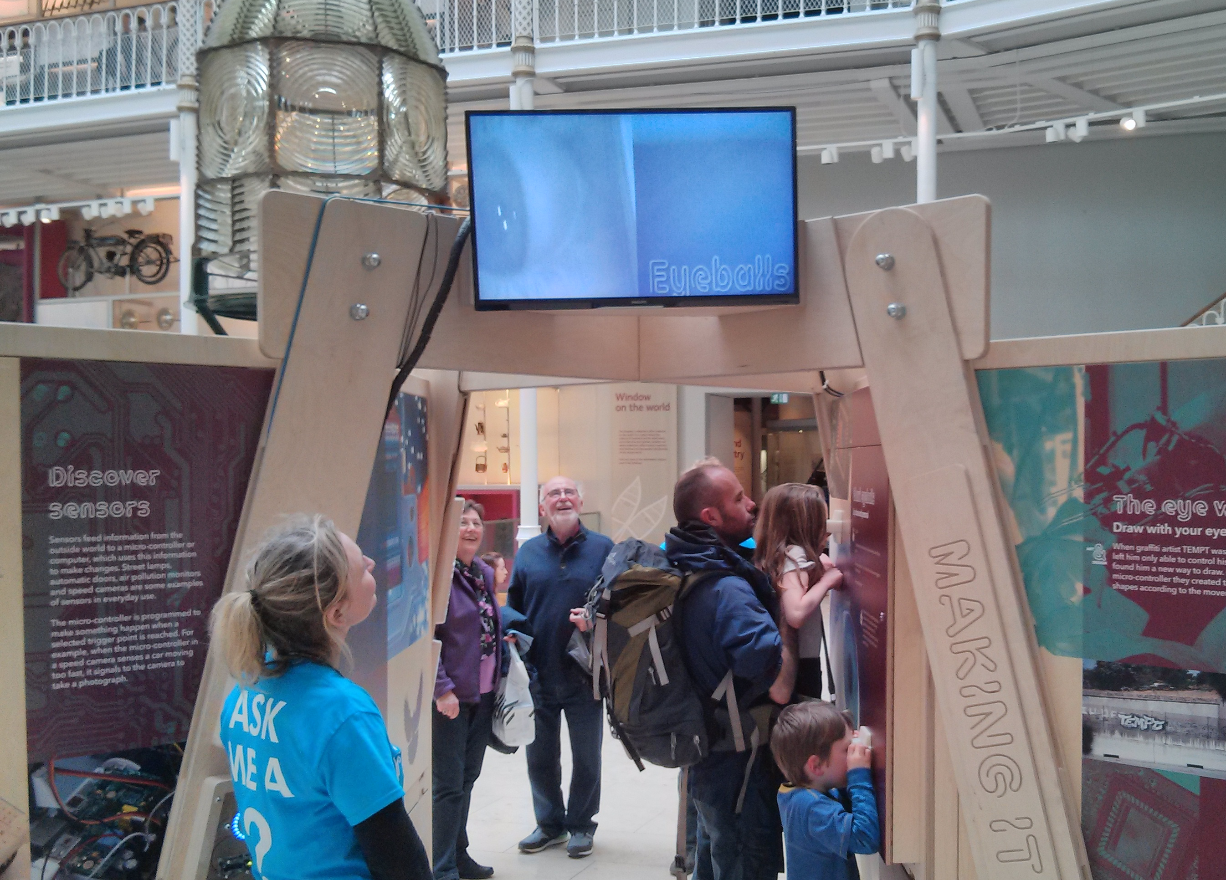

Figure 1: Giant Eyeballs at The National Museum of Scotland.
This investigation will examine intergenerational interactions around this piece and interpretations of the work. Focusing particularly on Don Norman’s (2005) discussion of emotions. (cf Weiss et al 2009).

Acknowledgements
We would like to thank all the volunteers and participants in this study. We would like to thank The Edinburgh International Science Festival and The National Museum of Scotland. Giant Eyeballs was co-designed by Tom Flint (Edinburgh Napier University), Yann Seznec (Lucky Frame) and Matthew Wright (Edinburgh International Science Festival).

References
- Al-Natour, S. and Benbasat, I. (2009) 'The Adoption and Use of IT Artifacts: A New Interaction-Centric Model for the Study of User-Artifact Relationships', Journal of the Association for Information Systems, 10, (9), pp. 661-685.
- Ameel, L. and Tani, S. (2011) 'Everyday aesthetics in action: Parkour eyes and the beauty of concrete walls', Emotion, Space and Society, 9, (3), pp. 1-10.
- Belk, W. (1988) 'Possessions and the Extended Self', Journal of Consumer Research, 15, (2), pp. 139-168.
- Borden, I. (2001) Skateboarding, Space and the City Berg: Oxford.
- Borgmann, A. (1984) Technology and the Character of Contemporary Life. The University of Chicago Press: Chicago.
- Carroll, J. Completing Design in Use: Closing the Appropriation Cycle (2004) European Conference on Information Systems. Turku, Finland,
- Childress, H. (2004) 'Teenagers, Territory and the Appropriation of Space', Childhood, 11, (2), pp. 195-205.
- Debord, G. (1967) The Society of the Spectacle. Zone Books: New York.
- DeSanctis, G. and Poole, M. (1994) 'Capturing the Complexity in Advanced Technology Use: Adaptive Structuration Theory', Organization Science, 5, (2), pp. 121-147.
- Dix, A. Designing for Appropriation (2007) 21st BCS HCI Group Conference. Lancaster University:British Computer Society.
- Gibson, J. (1986) The Ecological Approach to Visual Perception. Lawrence Erlbaum Associates: London.
- Giddens, A. (1984) The Constitution of Society. Polity: Cambridge.
- Heft, H. (2003) 'Affordances, Dynamic Experience, and the Challenge of Reification', Ecological Psychology, 15, (2), pp. 149-180.
- Luis, J., Manau, E., Mansilla, J., Jorge, O. and Solano, P. (2005) 'Squatting Geometries - Guerilla Barcelona', Architectural Design, 75, (6), pp. 58-63.
- McLuhan, M. (1964) Understanding Media. Routledge: London
- Merleau Ponty. (1962) Phenomenology of Perception: an Introduction. Routledge: London.
- Norman, D. (2005) Emotional Design, why we love (or hate) everyday things. Basic Books: New York.
- Orlikowski, W. (1992) 'The Duality of Technology in Organisations', Organization Science, 3, (3), pp. 398-427.
- Orlikowski, W. (2000) 'Using Technology and Constituting Structures: A Practice Lens for Studying Technology in Organizations', Organization Science, 11, (4), pp. 404-428.
- Salovaara, A. (2009) CHI 2009. Boston MA USA, Studying Appropriation of Everyday Technologies - a Cognitive Approach
- Sartre, J.-P. (1943) Being and Nothingness. Routledge: Bristol.
- Stevens, G., Pipek, V. and Wulf, V. (2009) Appropriation Infrastructure: Supporting the Design of Usages 2nd International Symposium on End-User Development. Siegen, Germany:Springer.
- Sun, H. and Zhang, P. (2006) Adaptive IT Use: Conceptualization and Measurement Fifth Annual Workshop on HCI Research in MIS. Milwaukee,
- Weiss, A, Wurhofer, D and Tscheligi (2009) I Love This Dog International Journal of Social Robotics Volume 1 Issue 3 pp 243-248.
- Whyte, W.(1988, Director) The Social Life of Small Urban Spaces Municpal Art Society of New York.

