Expanding the Child Visitor Experience – mixing realities in a contemporary sculpture park

Lynne Hall,
Faculty of Computer Science,
University of Sunderland, Sunderland, SR6 0DD, UK.
lynne.hall@sunderland.ac.uk
Tom Flint,
School of Computing,
Edinburgh Napier University, Merchiston Campus, Edinburgh, EH10 5DT, UK
t.flint@napier.ac.uk
Nicole Mitsche,
Faculty of Business, Law and Tourism,
University of Sunderland, Sunderland, SR6 0DD, UK
nicole.mitsche@sunderland.ac.uk

Abstract
This research considers how the visitor experience could be enhanced through intertwining and blending the real and virtual, creating a new mixed reality that extended and added to the destination. We discuss work undertaken with Jupiter Artland, a contemporary sculpture park in Scotland. Our focus was on co-creating a mixed reality for 8-11 year olds to enhance their visitor experience.
Technology is increasingly used in cultural spaces, long recognised as an attractor to engage children in museums and with culture (Roussou, 2004), with a range of apps available to enhance and extend the child visitor experience (Shrikant, 2017). Interpretation needs to be specifically designed with children in mind, engaging in their realms rather than the adult way of understanding (Tilden, 1957) and experience. Mixed Reality which aims to exploit the contextual space between real and virtual environments offering new ways to participate and engage is an ideal communicator in the world of technology experienced children. Nintendo’s Pokémon Go has ably demonstrated how gamification can result not only in novel ways of digital engagement but also new ways to experience the real world (Burke, 2014).
In developing our mixed reality visitor experience, we had Jupiter Artland and its virtual twin constructed in Minecraft, a creative game popular in the researched age group.
Jupiter Artland displays realised commissioned proposals from invited artists. Artworks are typically large scale and aim to have a significant impact on visitors. For example, in figure 1, Jencks’ Cells of Life, on the central path there are 3 people highlighting the size of the artwork. Artists spend time in Jupiter Artland and produce work specifically for a chosen space within the grounds.
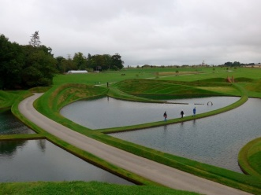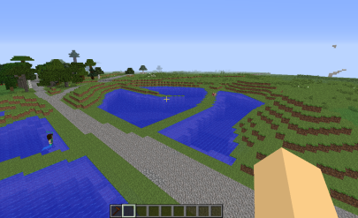
Figure 1. Cells of Life at Jupiter Artland and in Minecraft
Virtual Jupiter Artland is a facsimile of the real, a complete, geographically accurate and to scale version of Jupiter Artland constructed in Minecraft, see figure 2. Although Minecraft is a world creation game, this feature is disabled, with virtual Jupiter Artland presented as a finished space to be visited.

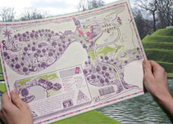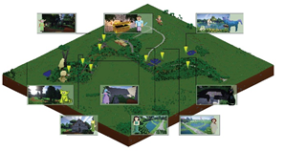
Figure 2. Jupiter Artland paper map and Jupiter Artland in Minecraft
Our goal was to use Virtual Jupiter Artland, in situ at Jupiter Artland, to create an engaging and memorable experience that mixed the real and virtual, providing 2 parallel but interconnected realities.
Co-creating with the same class of children over 3 years, we developed an integrated storytelling (role-playing narrative) and gamified (treasure hunt) approach that blended the real and virtual sculpture parks, and required the children to explore in both the real and virtual. Whilst for some children, the gaming element of the treasure hunt was the main motivation, for many this motivation emerged from engaging in the pretence that the narrative and virtual world are real. This pretence and the experience increased interest in the artworks with children having increased awareness of the artworks through the stories and memories they were attaching to them.
These results have contributed to the development of a framework within which we can take children across the conceptual barrier of the real and the virtual multiple times enhancing and extending the child visitor experience. Our findings highlight that scaffolding the canonical trajectory (that is the path through the experience selected by the curator or designer rather than that selected by the participant) with storytelling and gamification enables us to support the child visitor’s transitions between real and virtual and their progression through the park.
References
Burke, B., 2014. Gamify: How Gamification Motivates People to Do Extraordinary Things. Bibliomotion, Inc.
Roussou, M. (2004). Learning by Doing and Learning Through Play: An Exploration of Interactivity in Virtual Environments for Children. Comput. Entertain., 2(1), 10–10. https://doi.org/10.1145/973801.973818
Shrikant, A. (2017, May 10). 10 Museum Apps to Make Your Family’s Visit Easier. Retrieved 27 January 2018, from https://www.mommynearest.com/article/10-museum-apps-to-make-your-familys-visit-easier
Tilden, F., 1957. Interpreting our Heritage. University of North Carolina Press, Chapel Hill.

