Appendix A
Recommended Inclusions for a Best Practice Approach to the Management of Workplace Bullying (Woodrow and Guest, 2013)
Policy | - A statement of organisation’s ownership of / opposition to bullying
Document | - A definition of bullying and harassment
 | - A description of informal routes to address bullying
 | - A guide to formal routes if informal routes are not effective
 | - An explanation of mediation
 | - An explanation of complaints, grievance and disciplinary procedures
 | - An explanation of the responsibilities of managers
 | - An outline of investigation and support procedures
 | - Information on the monitoring of the policy
Promotion of | - Awareness campaigns
Policy | - Posters
 | - Leaflets
 | - Intranet
 | - Email communications
 | - Staff handbook
 | - Leaflets
 | - Internal magazines
 | - Videos
 | - Lectures, discussions and organisation wide meetings
 | - Appointment of a representative
Staff training | - Training for all new recruits at all levels at induction  - Training at least once a year for all employees*
 | - Training for complainants and accused
Informal routes | - Employee-volunteer advisory networks
for resolution | - Signposting services / help lines
 | - Human Resources
 | - Mediators
 | - Trade union representatives
Formal routes | - Investigation by internal / external people
for resolution | - Disciplinary procedures
 | - Trained investigators
 | - Trained mediators
 | - Support staff
Support for | - Professionally trained counsellors
victims, | - Occupational health services
Accused | - Rehabilitation services
and supporters | - Reintegration services
 | - Help line services
Systematic | - Absence data
Data | - Exit data
monitoring | - Staff attitude data
 | - Reports from support professionals
 | - Training data
 | - Levels of formal complaints
Note. *Modified from Woodward and Guest (2013)

Appendix B (on-line only)

Slope Analysis Moderated Mediation

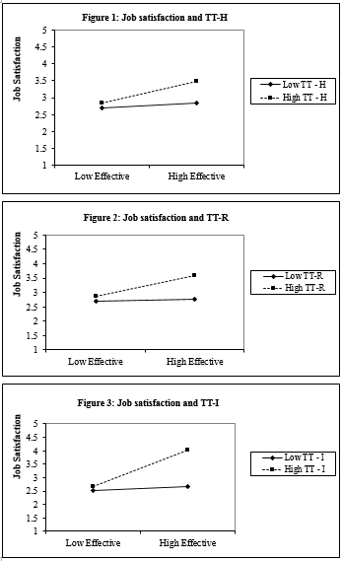
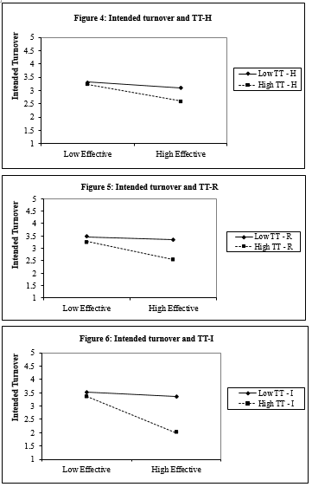

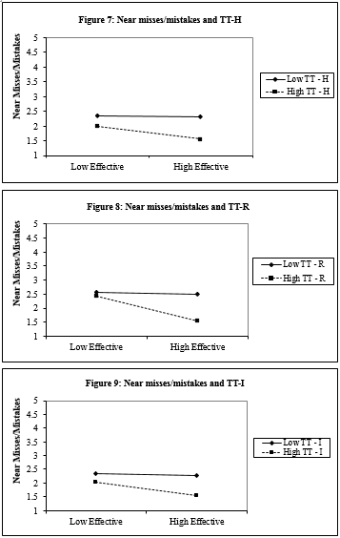

Appendix C (on-line only)
Tests for Moderated Mediation
Bootsrapped 95 per cent CIs
(Selig & Preacher, 2008)

In units with high targeted training incidence, results revealed significant conditional indirect effects of workplace bullying 95 per cent CIs between [0.06 and 0.51] for job satisfaction; 95 per cent CI between [0.08 and 0.26] for intended turnover; and 95 per centCIs between [0.15 and 0.42] for near misses; for targeted training hours 95 per cent CIs between [0.06 and 0.24] for job satisfaction; 95 per cent CIs between [0.02 and 0.18] for intended turnover; and 95 per cent CIs between [0.04 and 0.21] for near misses; and for targeted training resources 95 per cent CIs between [0.15 and 0.38] for job satisfaction; 95 per cent CIs between [0.06 and 0.23] for intended turnover; and [0.07 and 0.28] at 95 per cent CIs for near misses.
In units with low targeted training incidence, results revealed insignificant conditional indirect effects of workplace bullying 95 per cent CIs between [-0.13 and 0.30] for job satisfaction; 95 per cent CIs between [-0.07 and 0.19] for intended turnover; and 95 per cent CIs between [-0.10 and 0.18] for near misses; for targeted training hours 95 per cent CIs between [-0.08 and 0.19] for job satisfaction; 95 per cent CIs between [-0.12 and 0.16] for intended turnover; and 95 per cent CIs between [-0.10 and 0.17] for near misses; and for targeted training resources 95 per cent CIs between [-0.26 and 0.20] for job satisfaction; 95 per cent CIs between [-0.09 and 0.27] for intended turnover; and [-0.10 and 0.26] at 95 per cent CIs for near misses.

