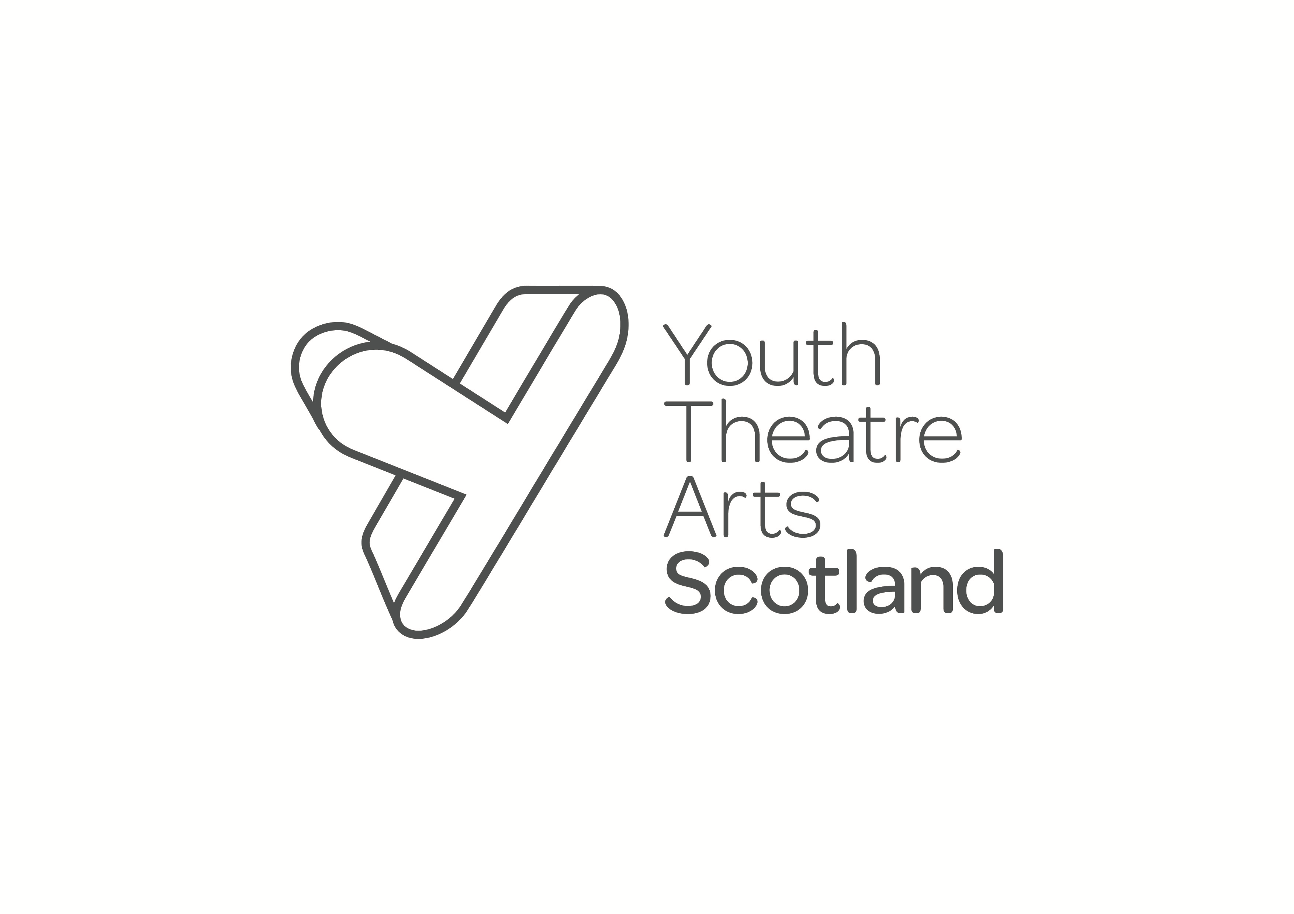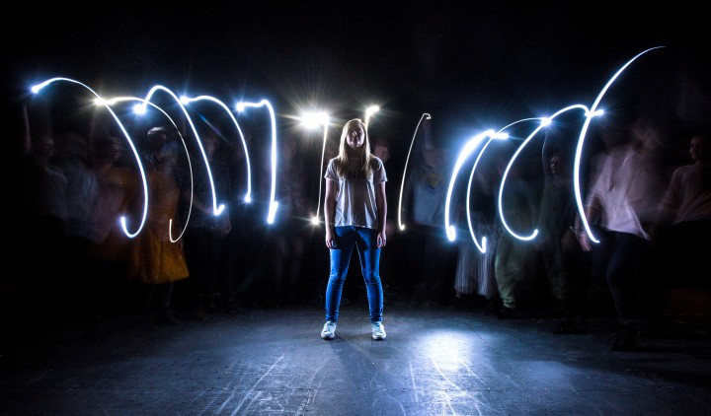

The Cancer Collaborative Theme at Edinburgh Napier University are hosting an exclusive **matinee performance** is being held on **the 18th November at 1.30 pm till 5pm** at the Traverse Theatre Edinburgh in partnership with The Youth Theatre Arts Scotland funded by Macmillan Cancer Support/Teaching Fellow Grant. Post-performance there will be an opportunity to participate in a round table discussion with Scottish Government, Health Care professionals and performers

Contact [w.mcinally@napier.ac.uk](mailto:w.mcinally@napier.ac.uk) for a Tickets



THERE IS A LIGHT: BRIGHTLIGHT