
Edinburgh Napier University
Sports Science Consultancy

Edinburgh Napier University
Sport, Exercise and Health Sciences
Human Performance Laboratory | Environmental Performance Laboratory

All of our Sport Science Consultancy sessions will take place in our State-of-the-Art facilities - our Human Performance Laboratory, or our Environmental Performance Laboratory. This document outlines the different Sport Science consultancy sessions that we offer. We are happy to tailor specific packages for athletes, so please get in touch for more information or to discuss options and pricing. Indicative pricing is included in the table on page 4 of this document but may be subject to change. All prices include a full report.

Email: seslabs@napier.ac.uk
Phone: 0131 455 2599

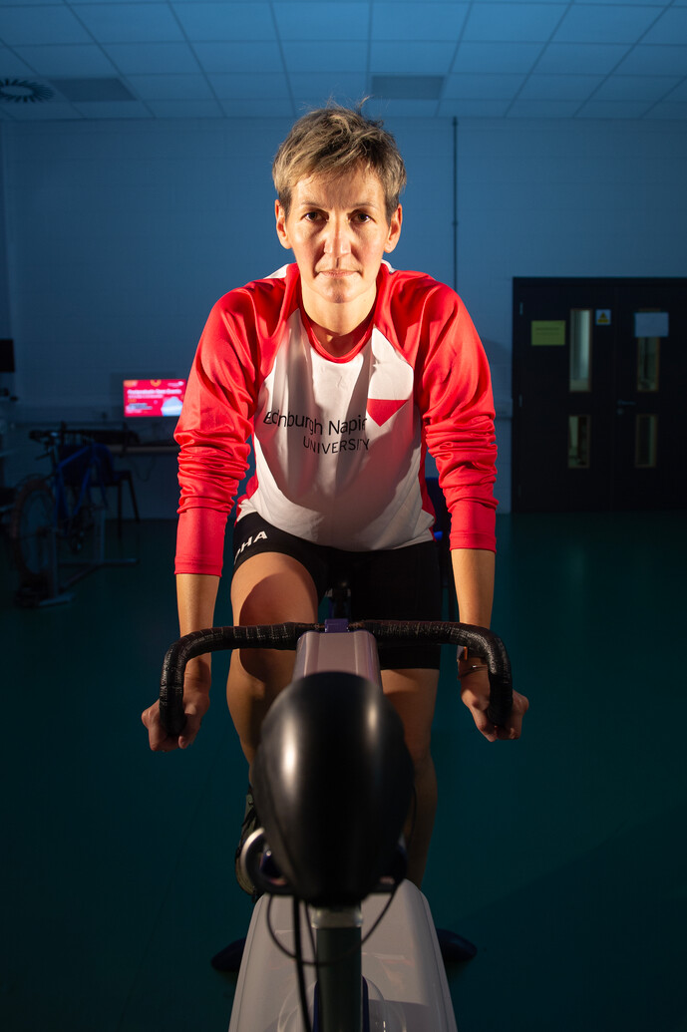
Physiological Assessment Information
Lactate Threshold
At rest and during lower intensity exercise conditions, the balance between blood lactate production and removal are generally equal. When exercise intensity increases, so does the rate of lactate production, and eventually will exceed the rate of removal. During a Lactate Threshold test, you will undertake an incremental test, starting at a low intensity. Each stage will last 4 minutes to allow your body to enter a steady state. During this test we will:
- Identify and report the point at which blood lactate production begins to increase above baseline levels (2mmol/L), known as LT1, and
- Identify and report the point where the secondary increase occurs (LT2), known as the Onset of Blood Lactate Accumulation (OBLA).
We will identify both the workload and heart rate at which both these thresholds occur, allowing us to set training zones (1-3) for you which can inform your training moving forward. During this test a small finger prick blood sample is required at the end of each incremental stage.
During this test we also have the option to collect breath by breath data which can give us information about running economy (RE) (if the test is performed on a treadmill) and also to collect and analyse date about substrate utilisation. During lower intensity exercises the body will use a mixture of Fat and Carbohydrates (CHO) as fuel, before changing to only CHO at higher intensities. By collecting breath by breath data, we can identify the workload at which this occurs, as well as reporting on the workload that elicits the greatest fat utilisation (FATmax).

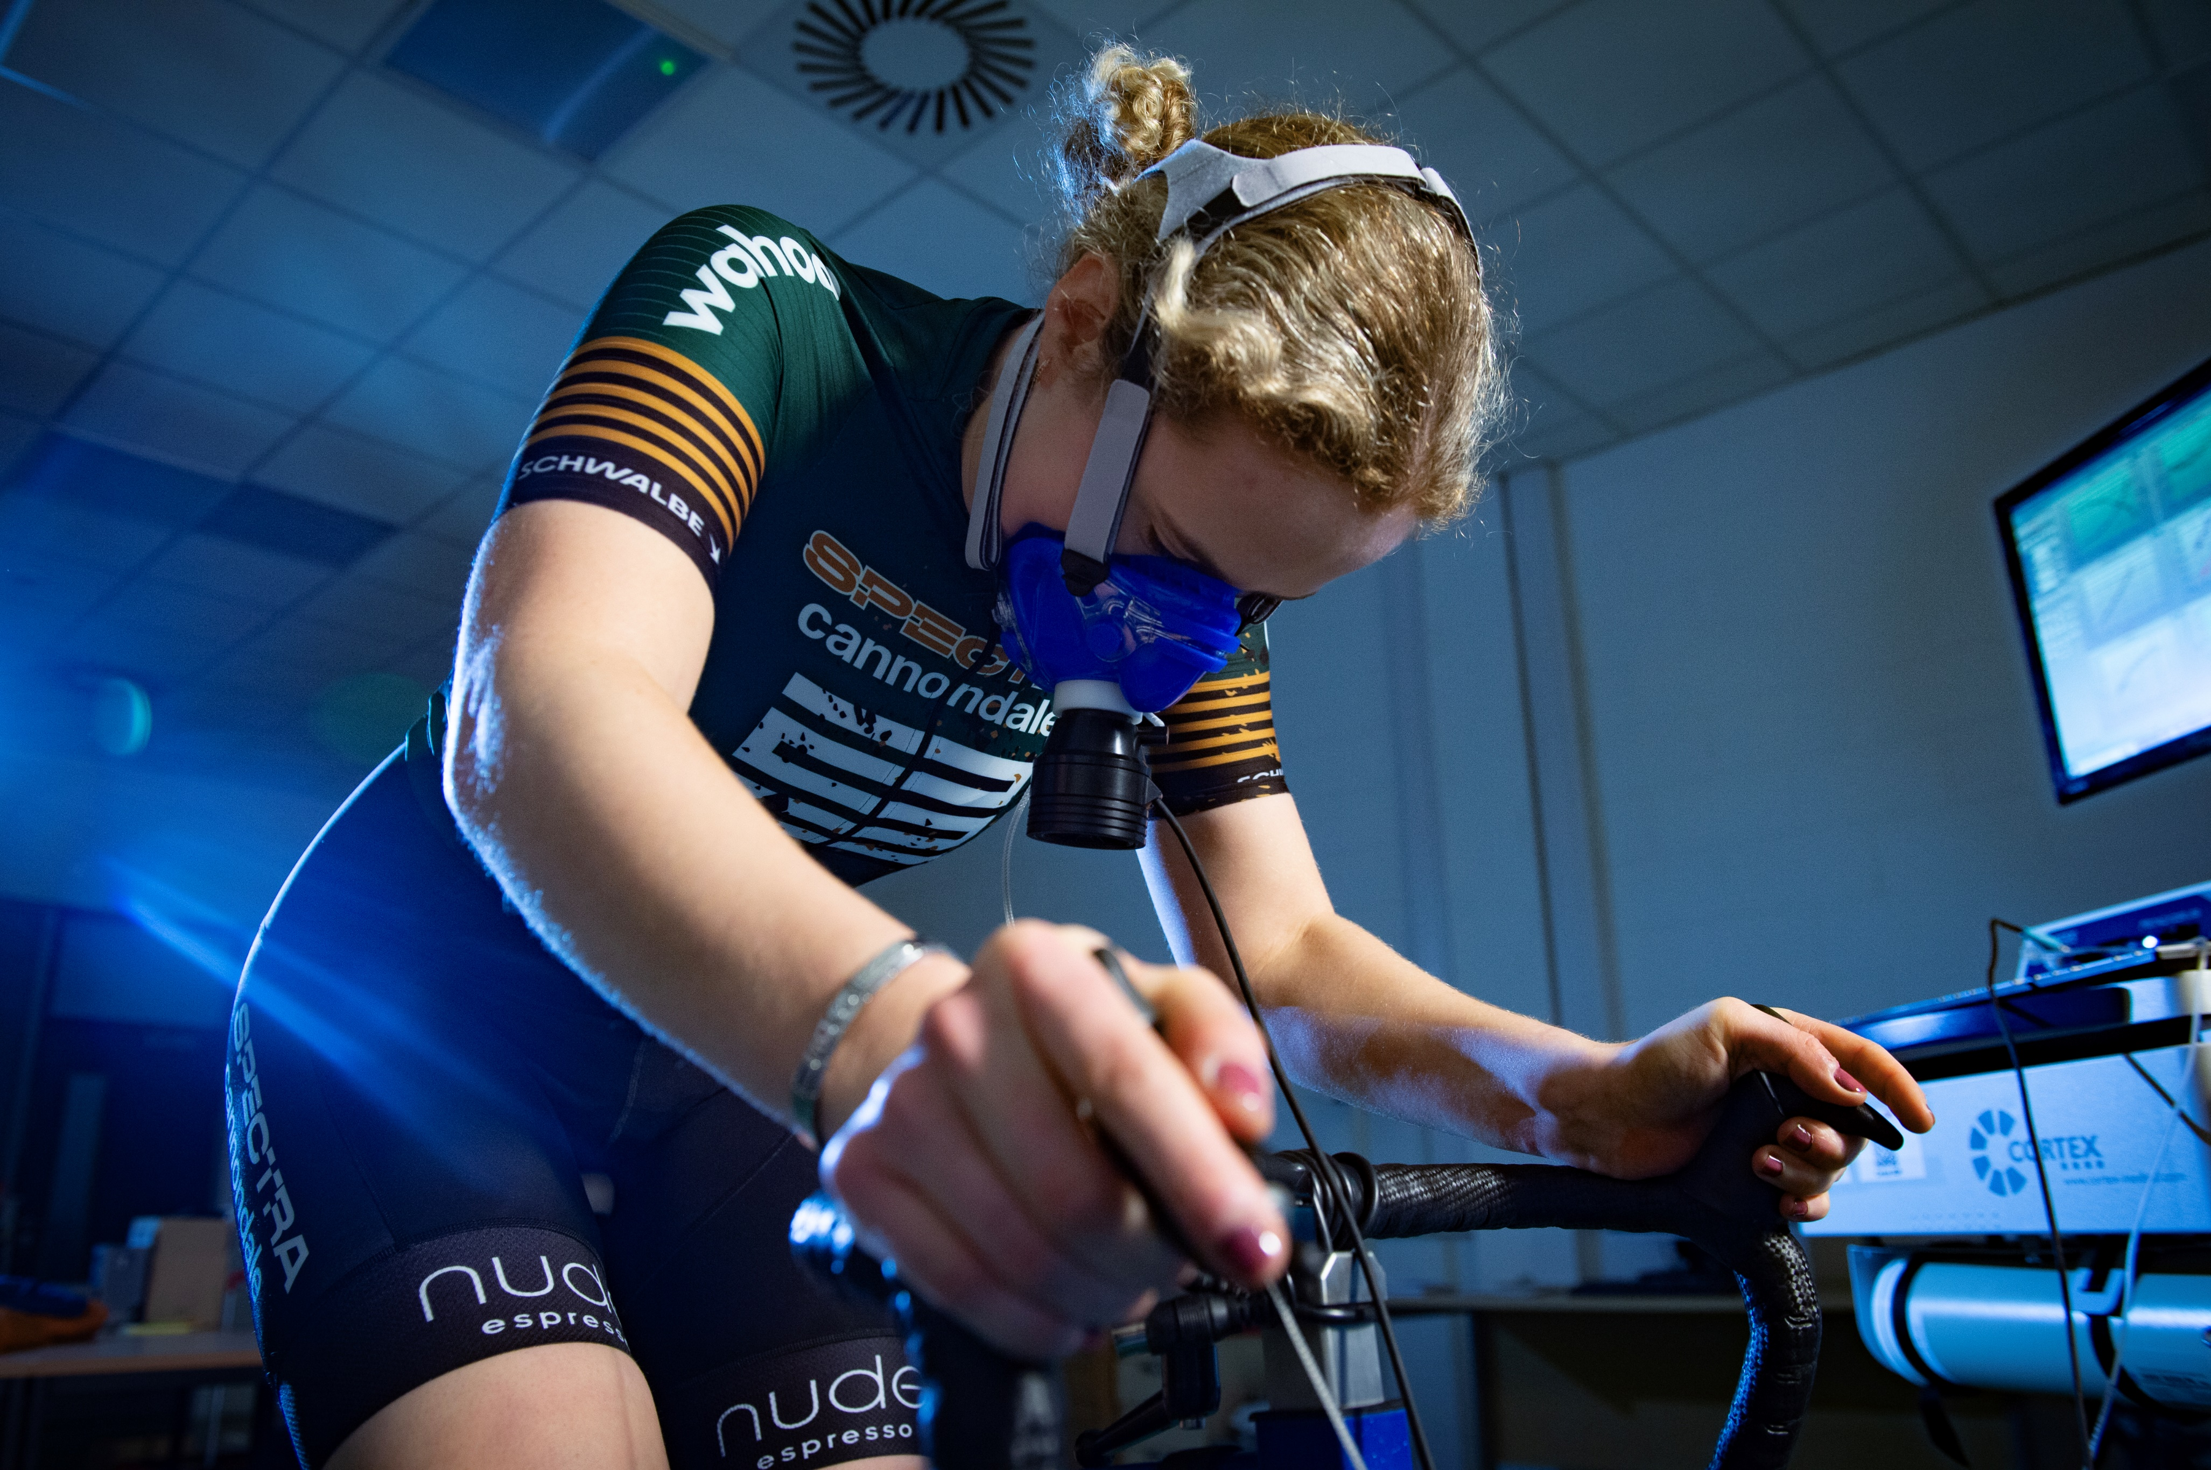
Physiological Assessment Information (cont.)
VO₂ Max
VO₂ Max is the highest rate at which oxygen can be utilised during exercise and is viewed as one of the most important performance predictors in aerobic sports. During a VO₂ Max test you will exercise at increasing intensity during an incremental test, with each stage lasting 1 minute, until volitional exhaustion. We will also identify your maximum heart rate, which alongside a Lactate Threshold test, can be used to complete your training zones (4 and 5).
If this test is completed on a bike, we can also identify Maxmal Power Output (MPO) and Functional Threshold Power (FTP), 2 other performance measures which can be used to predict cycling performance.

FTP/MPO
Functional Threshold Power (FTP) represents your ability to sustain the highest possible power output for 60 minutes. Maximal power output (MPO) is the maximum power you can sustain for 1 minute. To measure these performance variables, you will exercise at increasing intensity during an incremental test, with each stage lasting 1 minute, until volitional exhaustion. From this data we can identify MPO and accurately predict FTP. This test can be combined with a VO₂ Max test.

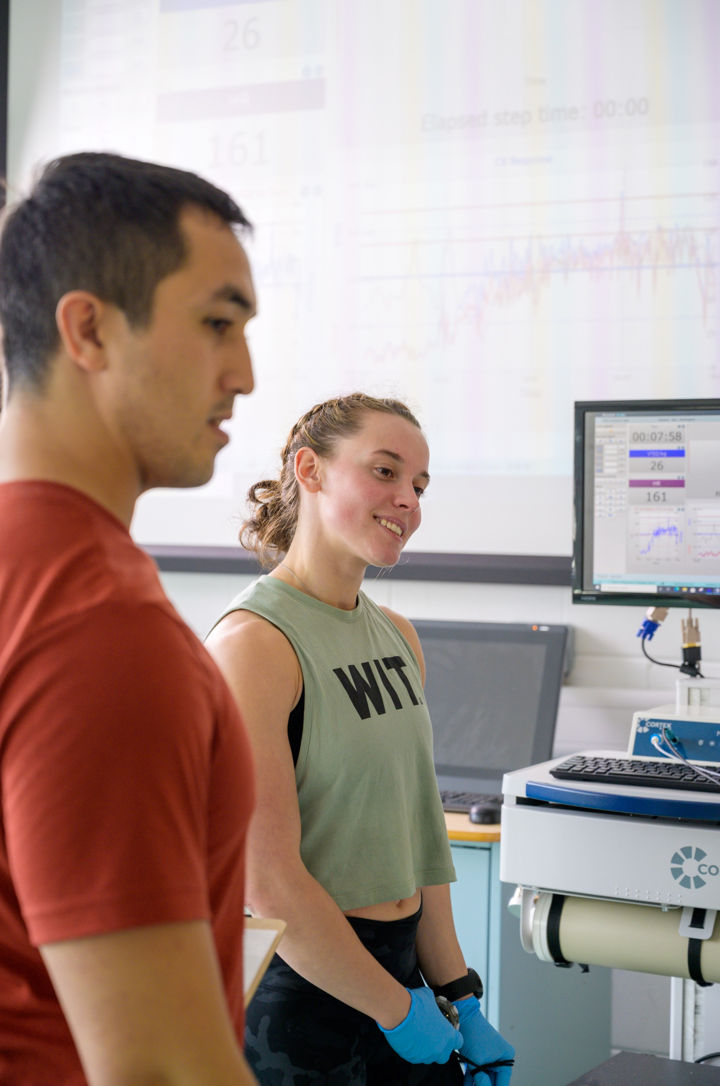
Physiological Assessment Testing Options
Cycling
- Lactate Threshold Only
- Add Substrate Utilisation (including FATmax)
- VO₂ Max Only
- PPO/FTP Only
- Lactate Threshold and VO₂ Max
- Add Substrate Utilisation (including FATmax)
- Lactate Threshold, VO₂ Max and FTP
- Add Substrate Utilisation (including FATmax)
Treadmill
- Lactate Threshold Only
- Add Substrate Utilisation (including FATmax) and Running Economy
- VO₂ Max Only
- Lactate Threshold and VO₂ Max
- Add Substrate Utilisation (including FATmax) and Running Economy

We also offer Anthropometric assessments (sum of 8 skin folds) and this can be undertaken on its own, or combined with any of the above testing options (subject to staff availability).

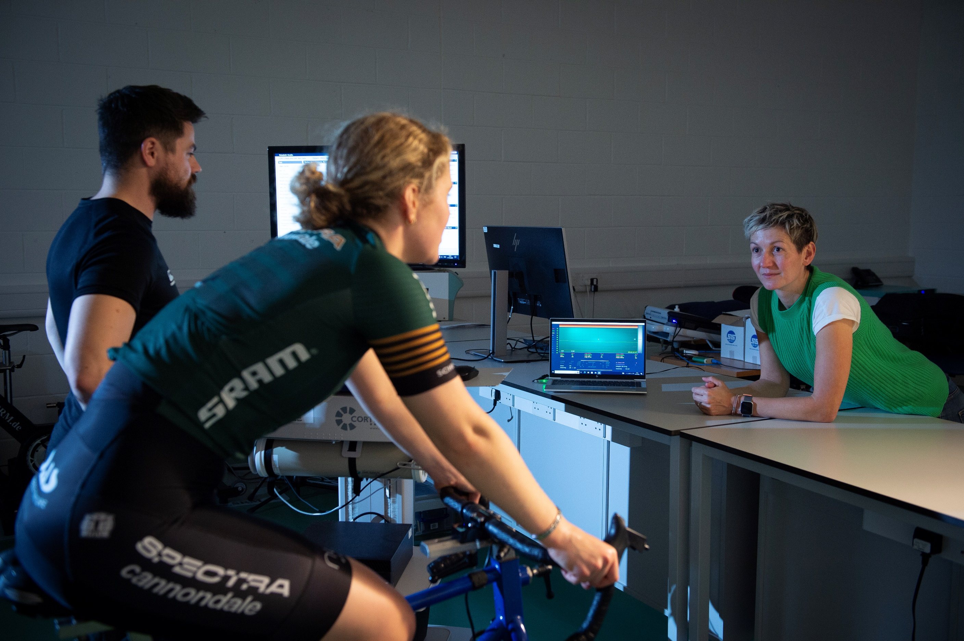
Table 1 – Prices for Cycling Physiological Testing and Associated Report
Table 1
Testing Option | Price | With substrate utilisation and included
Lactate Threshold Only | £90 | £108
VO₂ Max Only | £90 | n/a
Lactate Threshold and VO₂ Max | £162 | £180
FTP Only | £90 | n/a
Lactate Threshold, VO₂ Max and FTP | £180 | £198

Table 2 - Prices for Treadmill Physiological Testing and Associated Report
Testing Option | Price | With substrate utilisation and RE included
Lactate Threshold Only | £90 | £108
VO₂ Max Only | £90 | n/a
Lactate Threshold and VO₂ Max | £162 | £180

Table 3 - Prices for Anthropometric Testing and Associated Report
Testing Option | Price
Anthropometry Only | £60
Anthropometry Add-On | £48

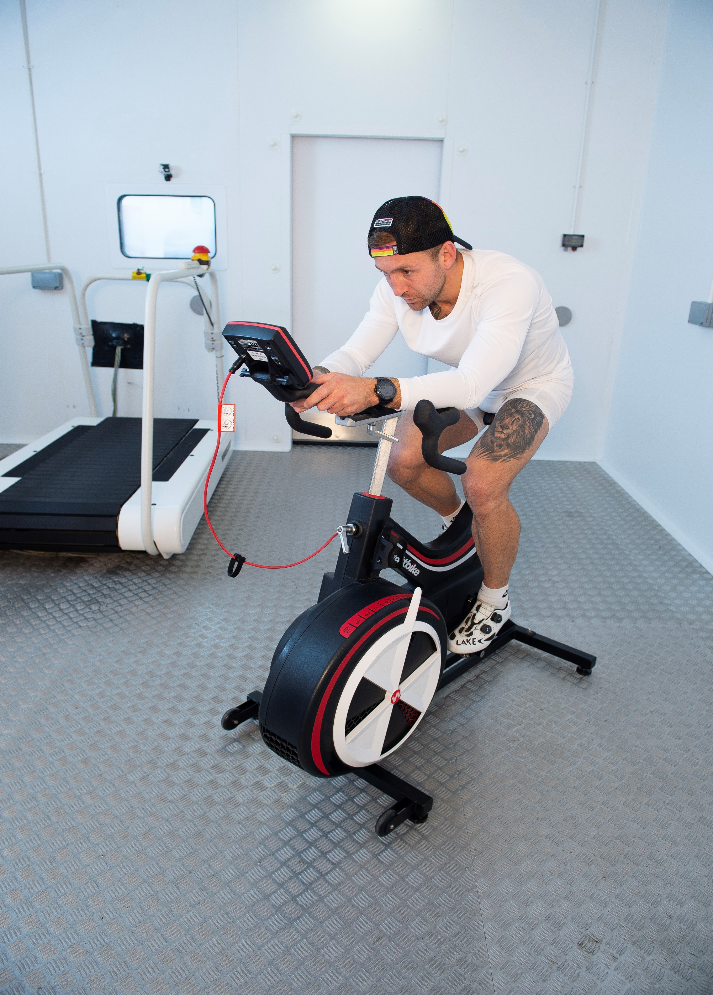
Acclimation Options
Acclimating to the environment you will be competing in is vital to ensure you not only perform at your best, but also understand how you react physiologically and can manage this accordingly to remain safe. We will tailor a package to your individual needs, ensuring you get the most out of the sessions in our Environmental Performance Laboratory. We can work at temperatures up to 50°c, down to -10°c, up to 95% humidity and also replicate the oxygen content to over 5000m, the same as Everest Base Camp.
We have worked with some of the best Ultra Endurance Athletes in the world to prepare them to compete in the extreme conditions they will face, including the Marathon Des Sables and various races in the “Beyond the Ultimate” series (ForRangers, Desert, Jungle). It is not only ultra endurance athletes we work with, we have also helped athletes and teams prepare for, amongst others, the following events:

- Enduro World Series – Colorado
- World Cup XC MTB – Switzerland, Italy.
- UTMB – Mount Blanc Ultra
- The Breck Epic MTB stage race – Colorado
- Ironman – Austria, Lanzarote, Nice, Kona
- Under 19 Cricket World Cup – South Africa
- Touch Rugby World Cup – Kuala Lumpur
- Under 20 Rugby World Cup - France
- European Club Hockey Championships – Turkey

If you are currently training for any event in a foreign climate, please get in touch for more information and to find out how we can help you. Sessions in the Environmental Performance Laboratory start at £50/hour (£60 including VAT).


Sheila Sanei
Beyond The Ultimate (Desert) 2023
5 days | 250km | > 50°c

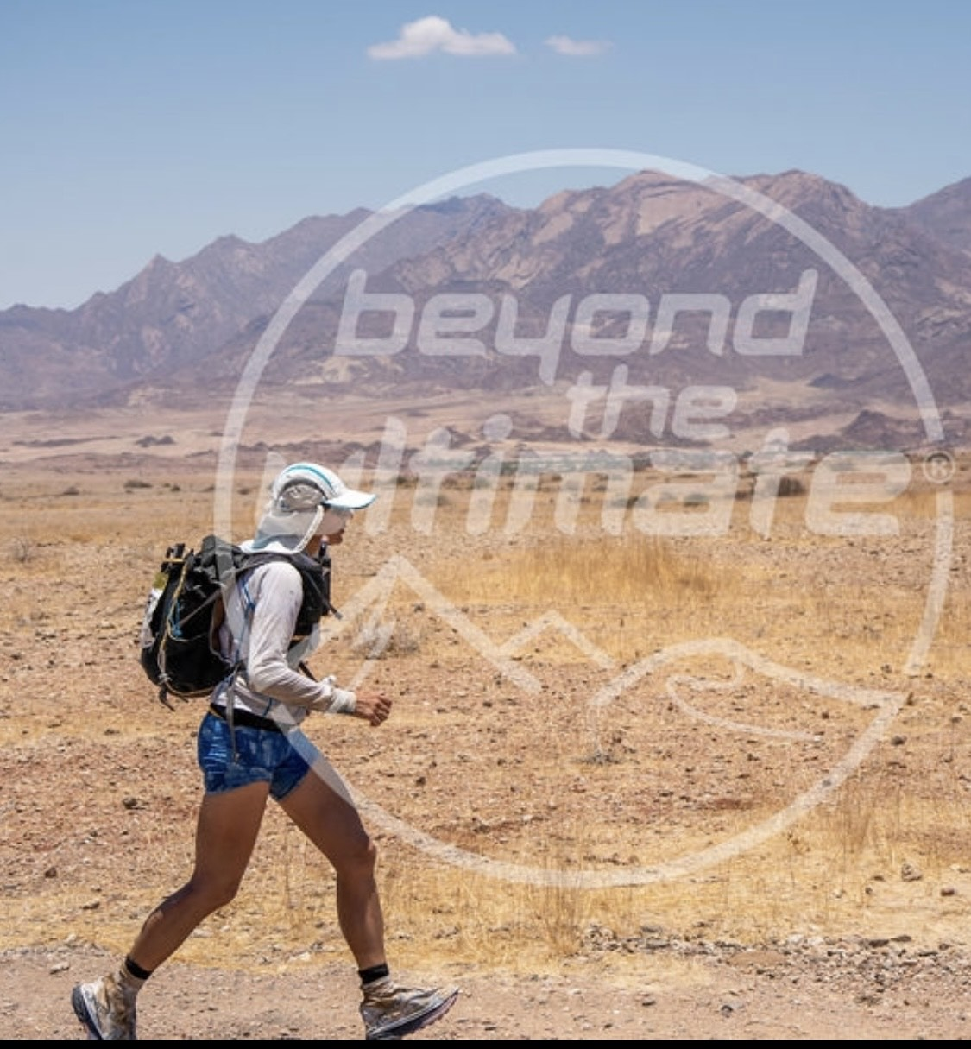
Testimonial:
I am very grateful having been supported by Neil and Lesley at the Napier science lab in the final weeks of my preparation for the Namibia 250 km desert race.

That included sessions in the heat chamber building up to training in 50 degrees, sweat analysis and constant and very close monitoring of the body core temperature as well as heart rate whilst training in the heat chamber .

The plan they designed for me was absolutely spot on as I ended up racing in 53 degrees heat in Namibia and knowing I had trained in the heat chamber certainly provided me with a physical and mental edge.

The support and encouragement of Neil and Lesley was invaluable and I can’t recommend them highly enough for anyone wanting to prepare for races in extreme heat or high altitude.
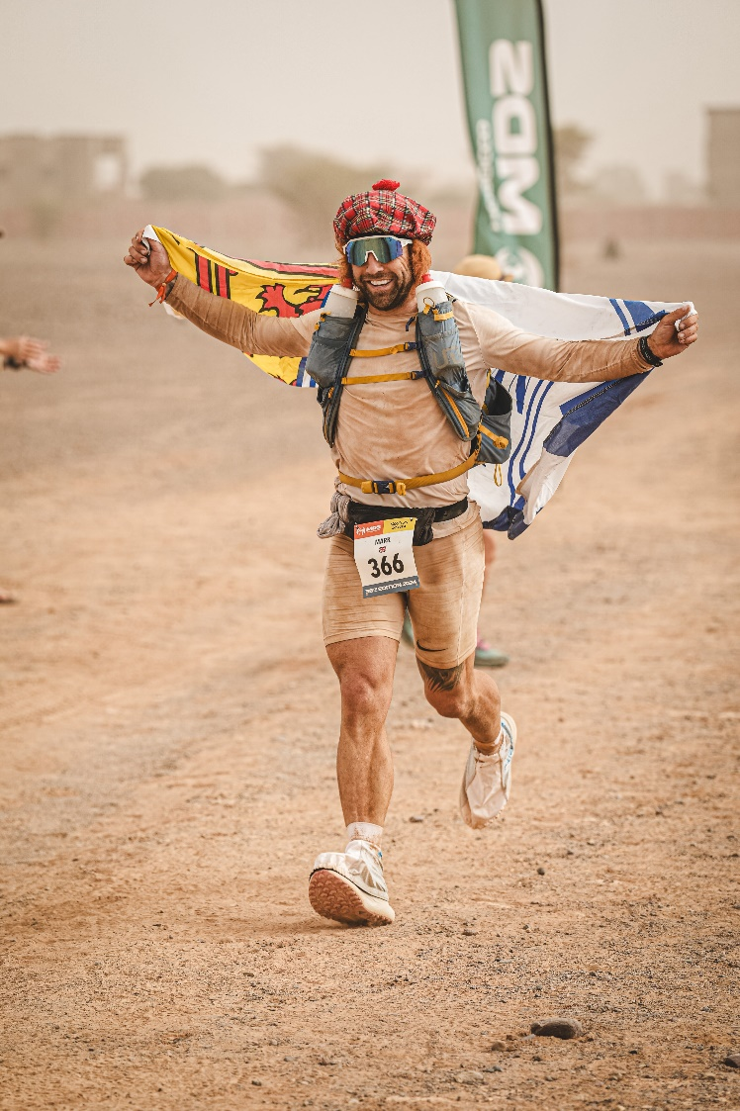

Mark Innes
Marathon De Sables 2024
6 days | 230km | > 50°c

Testimonial:
“I am incredibly grateful for the opportunity provided by the Edinburgh Napier University Sports Science Department to train in their cutting-edge environmental chamber for my preparation for the Marathon Des Sables.
The chamber not only simulated the extreme conditions of the race but also allowed me to optimise my training regime in a controlled environment.
Thanks to the department's support and resources, I felt better prepared both physically and mentally for the challenges ahead.
Their dedication to providing athletes with top-notch facilities truly sets them apart. I cannot thank them enough for their invaluable assistance in helping me achieve my goals.”
Danny Johnston
Beyond The Ultimate (ForRangers) 2023
5 days | 230km | ~35°c | ~65% Humidity | >2000m

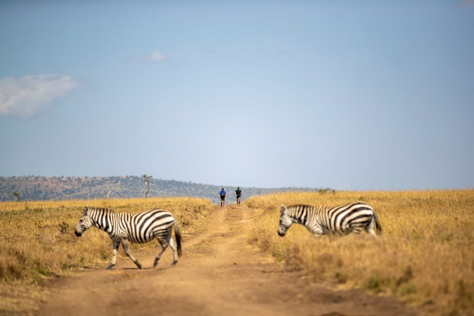
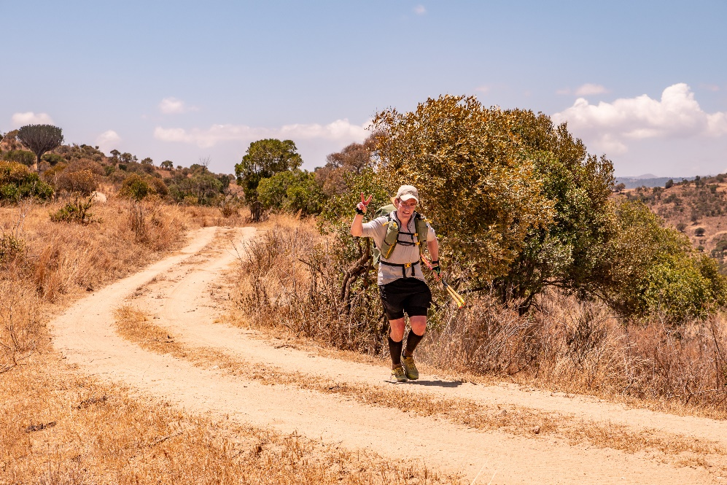
Testimonial:
“The ForRangers Ultra is a 230KM race over 5 days across the open grasslands and savannahs of Kenya. The race is primarily to raise awareness and funds for the rangers who protect the remaining communities of African black and white rhinos from poachers. The challenging terrain varies from baking grasslands, rocky hills, riverbeds and montane forest.
When I first signed up for the ForRangers Ultra at the beginning of 2023, the thing that worried me most wasn’t the distance or even wild animals, but the exposure to heat (35 degrees), humidity (63%) and the elevation (>2000M) over a prolonged 5 stage race.
Napier University’s Sports Exercise and Health facilities were just what I needed to help me build some adaption and confidence for running in such a different and unique environment. Right from the first visit to the end of my 6 sessions, the expertise and professionalism of staff was just superb. With world-class facilities, I felt like the team led by Neil Guthrie really cared about my progress and could not have done enough to make me feel more welcome. They created a really supportive environment that helped me reach my goals.
I was thrilled to have completed the race in Kenya as there were a number of DNFs due to heat exposure. Thanks to the support and preparation I received from the University I was able to complete the race in fine form.
Big thanks to Neil Guthrie and the team for helping me achieve such a great outcome.”

Ian Stewart
Lactate Threshold/Vo2 Max Test

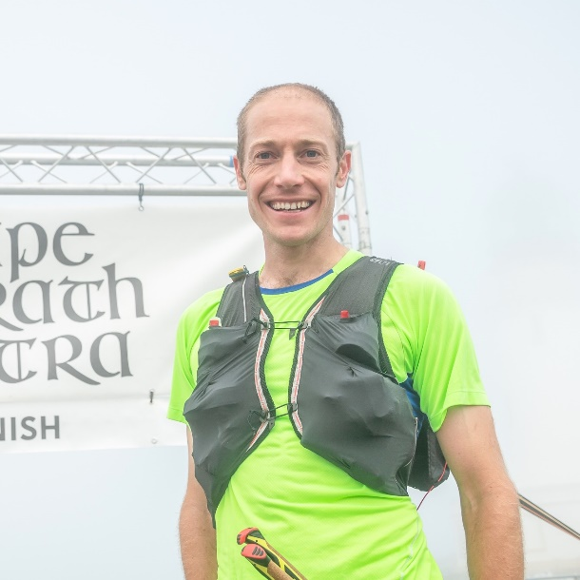
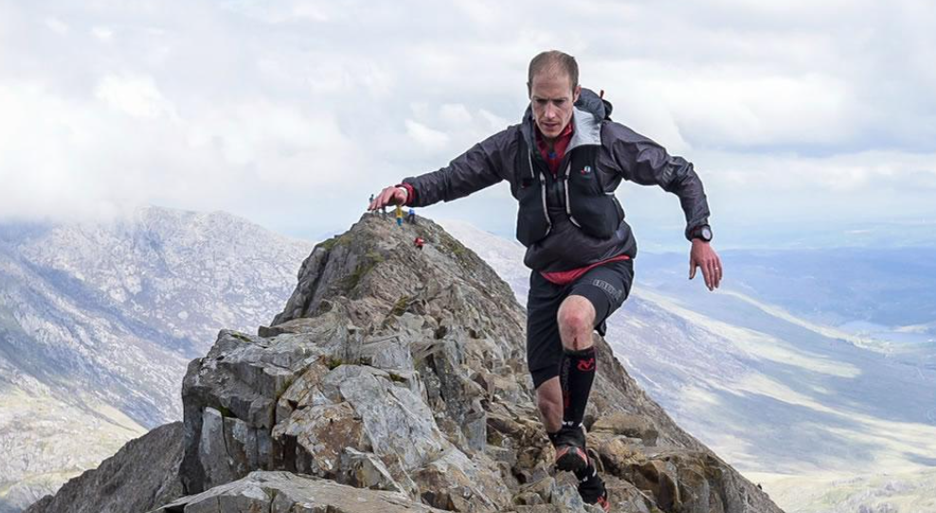
Testimonial:
"As a running coach I was interested to see what I could learn from the process of testing myself in the lab. The Napier team explained the process and results really clearly and answered loads of questions between tests. It was a fascinating couple of hours, and I went away with some clear data to help me tailor my training."

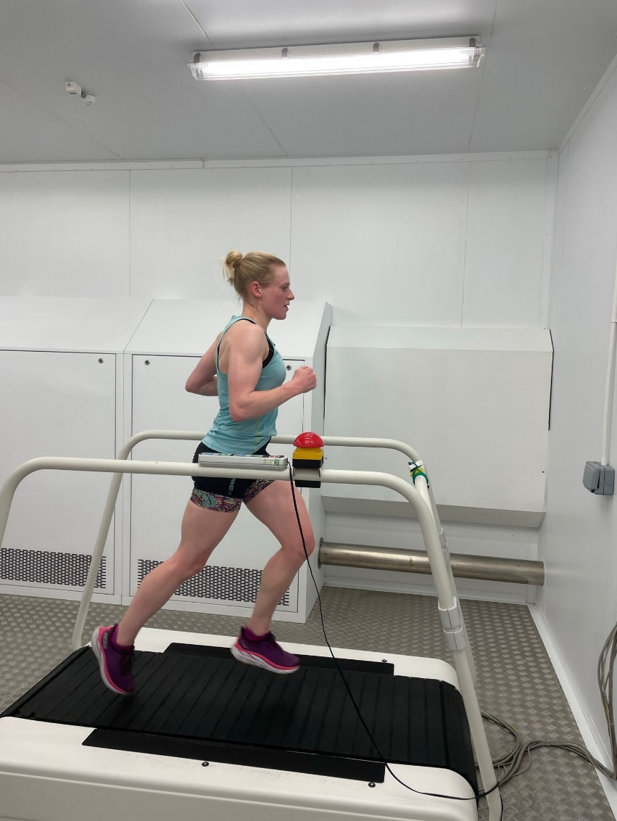
Watsonians Ladies 1’s
European Club Championships 2023
Alanya, Turkey | 30°c

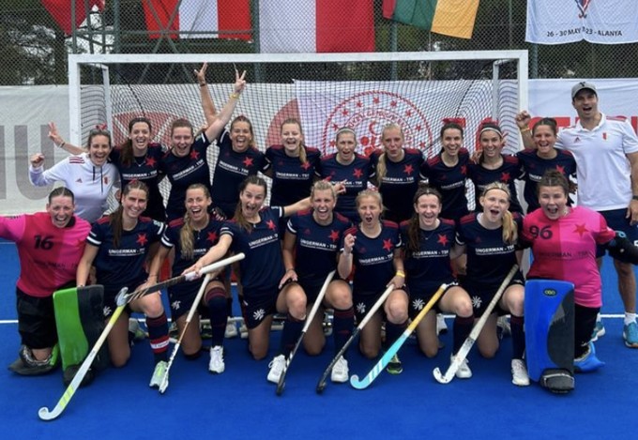
Testimonial:
We had a great experience in the Environmental Performance Lab at ENU. The sessions really helped us prepare for our European tournament in Turkey in June 2023. The staff were all super friendly, knowledgeable and gave us loads of useful information during the sessions. It was really easy to book, and they were also flexible with our work commitments with timings of the sessions.

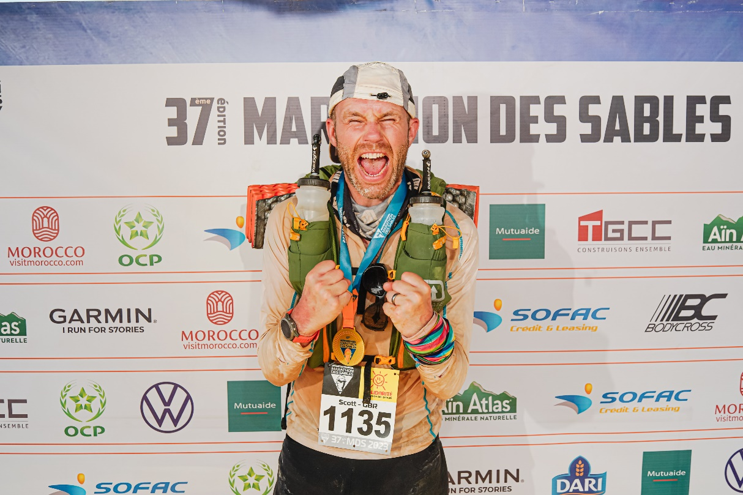
Scott Macdonald
Marathon De Sables 2023
6 days | 230km | > 50°c

Testimonial:
“I used the SES Lab as part of my training for Marathon Des Sables in the Sahara Desert. I couldn’t speak high enough of the team and the facilities; it was all incredible.

My training plan was bespoke to the demands I was going to put on my body and where my training was currently at. Everything had been carefully thought through and was flexible enough to build around my training. I spent much of my time in the heat chamber where the team took great care of me, and this was absolutely critical to my race success.

First class facilities. First class people, knowledge, and support. I’ll be back for sure”
Keith McQueenie
Lactate Threshold/Vo2 Max Test

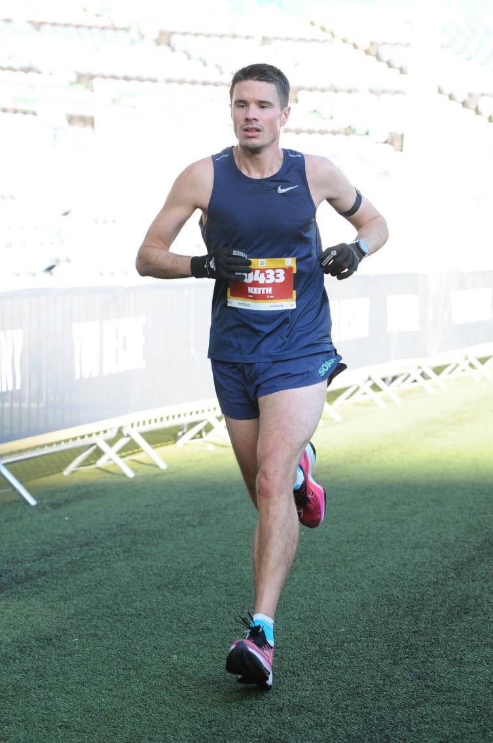
Testimonial:
“I was interested to learn more about my current level of fitness to help better inform half and full marathon training plans this year. I was particularly interested in gaining scientific insight on my bodies reaction to different heart rate zones and paces to take some of the guesswork from feel alone out of race day pacing strategies. The facilities at ENU are even better than I had expected, and Neil carefully explained all aspects of the testing process at each stage. The report received following the test contained all the anticipated fitness metrics but with additional context to help me digest and apply this to my training. Thanks again to Neil and the team and see you in 6-12 months to do it again.”

